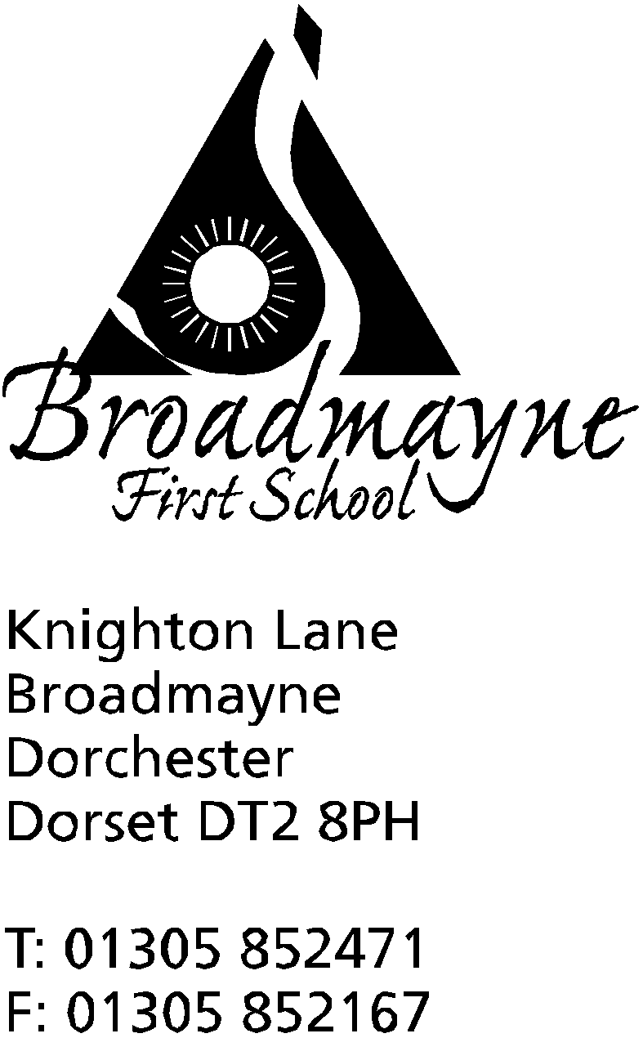

In Dorset

Headteacher
Helen Collings
Friday 6th 2019

Autumn 2019: Newsletter No 9.

Things to remember!
- Have you reserved your tickets for the Nativity play?
- The cut off date for ordering LFL Christmas lunch is Tuesday 10th December (to be served Tuesday 17th December)

Dear Parents and Carers,
As we near the end of term, this will be the last newsletter I write in 2019. The term has gone past so quickly, with so many exciting things taking place - I hope to share a ‘Good News’ round up of the term with you all before the holidays begin. I would like to extend my thanks to everyone who has supported the school this term, in any way at all - it’s fantastic that our school is at the centre of such a warm and supportive community, and we all look forward to strengthening our links in the new year.

Christmas Play
As you know, this year we have changed our plays around a little. A letter about tickets for the performances has been sent out, and although the changes might mean that your child is not directly performing in this particular play, we would really encourage you to come along, as the children have worked very hard to learn a wonderful selection of old and new Christmas songs for you to enjoy, and we all know how important a school nativity is to the run up to Christmas! All the children will still have their moment to shine on stage during our summer production, just as they did previously in the Christmas one. Mrs Bostock asks Years 3 and 4 to make sure they practise their words to the song, as they are an essential part of the performance.
There are still tickets available, and some families have not yet reserved any - we are extending the closing date for tickets until Monday 9th December, and I have attached another reservation form to this letter. After Monday we will offer any remaining tickets to families who would like extra.
The Dorset Echo will be coming along to take photos of the Year 1 children in their costumes next week - the date they are due to be published is the Wednesday 18th December edition of the paper.

Christmas Party Day
The last day of this term, Friday 20th December is Christmas Party Day. It will be a non school uniform day, but please ensure children are wearing clothes suitable for playing outside at break times! There will be a variety of fun activities throughout the day, and a buffet lunch will be served for everyone at lunchtime. We would like to invite you to contribute towards the cost of the day by making a donation of £1 on the SchoolMoney site. There is no obligation to do so, and we are very grateful for any contribution.
Please note that school will close at 2.30pm on this day.

Defibrillator
We are very pleased to announce that not only have we raised the money for the defibrillator, but that we have now installed it and it is ready to use! Many thanks to Martin Richardson, and Kenny Cresswell and Josh Brown of Weymouth Electrical Services for all their help with the installation.
To say thank you to our families who have helped raise the money for this project, the staff have put together a hamper of treats. We will put every family name into a hat and draw out a winning name later in the term.
Training for using the defibrillator will take place early next year and a session will be offered for those parents who would like to know how to use a defibrillator in an emergency situation.
In the meantime, in the event of an emergency, phone 999 and they will give you the code to access the machine.

Christmas Fayre update
A huge thank you to everyone involved with the Christmas Fayre this year, whether as a stall holder, volunteer or a visitor! It was a lovely evening, and we have had lots of people commenting on how much they enjoyed the variety of stalls, the outside food area, and the entertainment by our choir, the Starlings. The FABS raised £1647 which is an amazing amount!

Base Club
Base Club provides after school care from 3.15 pm until 6pm on Mondays, Tuesdays and Wednesdays throughout term time. Those of you who already use this service will know that Lin Reed has recently left the club, and Jess Welch will be working with Jackie Naylor in her place. The club runs lots of different activities throughout the week, and provides a light meal for the children who attend. There are currently vacancies if you would be interested in sending your child along - you don’t have to sign up for every day!

Mr Oxlee
We are sad to announce that Mr Oxlee, who works in Year 4 on a Friday, will be leaving us at the end of this term in order to pursue a new avenue in his teaching career. Mr Oxlee has worked in the school for several years, and we will miss him a great deal when he goes. I’m sure you will join me in wishing him well in his future career. Mrs Rosie Crumbleholme will be covering Fridays for us for the next two terms.

Children’s Christmas Cards
We have a request from our Year 4 children, who collect and deliver Christmas cards from the Christmas postbox. Please can you remind your children to write not only the name but also the year group of any children they are sending cards to on the envelope - we have lots of children with the same names and the Year 4s are finding it difficult to work out who to send them to!

Volunteering Opportunities
Year 4 are looking for two people to help with listening to children read. If you are able to commit to a regular time slot each week, please let us know.
Year 4 are also really keen to start a craft club. This would be during an afternoon, with a very small group of children. If you have an interest in crafts, or are keen to get involved, please think about volunteering!
If you are interested in either role, please let the school office know or speak directly to Ms Carter-Grogan - the whole of Year 4 would be very grateful!

Wessex FM - Sleeps ‘Till Christmas
Our choir, the Starlings, have been invited to contribute to Wessex FM’s Christmas countdown song. If you have heard this performed on the radio or seen it on the Wessex FM website, each day a group of children sing a verse of a song counting down how many sleeps it is until Christmas day. Our children will be performing on the 23rd December - when there will not be many sleeps at all left! Please listen out for them or check out the website to watch their performance.

Clubs
The clubs letter for next term will be sent out before the end of term so that you can sign up children ready for next year. Please make a note of when clubs start and finish - if children are not collected at the end of a club staff cannot look after them-we will have to place them in after school care and you will be charged accordingly.

Snapshots
Snapshot reports for Years 1 - 4 will be sent out in the final week of term. As these are the end of term Snapshots there will be an extra section reporting on your child’s progress towards their end of year targets.

We look forward to seeing you at one Christmas play performances.
Yours faithfully,

Mrs Collings

Date | Time | Event
December
Mon 16th | 2pm | Christmas play
Tues 17th | 9.30 am  5.00 pm | Christmas play  “ “
Weds 18th |  | Year 1 trip to the Shire Hall
Fri 20th |  | Last day of term; Christmas party lunch- school finishes at 2.30 pm
January 2020
Mon 6th Jan |  | Back to school - First day of Spring Term
Mon 13th |  | Dress Like A Rockstar Day - details to follow!
Fri 17th | am | Y4 visiting St Mary’s Middle for science workshop
Fr 31st | 1.30 -2.30 pm | YR Dance showcase at St Mary’s Middle School

School Christmas Performance 2019
Ticket Request - Please return by Monday 9thDecember 2019

Child’s Name: ……………………………………….……… Class: ……………………..

Parent’s Name: …………………………………………………………….

We would like our TWO tickets for:-
(Please tick below. You may split your choice i.e. 1+1. Apologies but only 2 tickets maximum per family)

Monday 16th December  2pm - School hall | Tuesday 17th December 9.30am - School hall | Tuesday 17th December  5pm - School hall

