This half term the Year 1 topic will be...
In Science we will continue to watch our sunflowers seeds that we planted before Easter grow and develop. We will identify and name a variety of everyday materials, including wood, plastic, glass, metal, water and rock. We will describe the simple physical properties of everyday materials and compare and group together a variety of everyday materials on the basis of their simple physical properties. We will continue to carry out some simple investigations to practise our skills of prediction and close observation.
In English we will continue to practise our phonics daily. We will continue to learn how to form our letters using a cursive formation. We will continue with whole class and guided reading sessions where we will learn about the features of Traditional Tales. We will start with Jack and the Beanstalk to provide a link with last term’s learning about plants and then move on to our main text this half term which will be ‘The Three Little Pigs.’ We will focus on learning to tell the story off by heart using a story map to help us. We will then write the story but add our own twist to the tale! We will recap how to use a question mark by writing questions to ask a staff member who has worked at the school a long time and write a poem about our school grounds. We will continue to learn about basic punctuation and a practise using an exclamation mark. We will introduce the -ed and-ing suffix.

“Brilliant Broadmayne!”

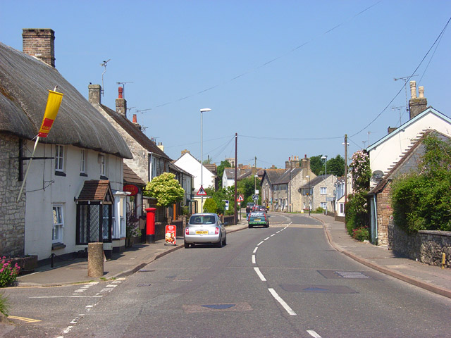

In Maths we will continue to look at numbers to twenty and ordering and comparing numbers to twenty. We will think about what the two digits in the teens numbers represent and use dienes to help us learn the value of these numbers. We will then move on to addition and subtraction within 20. We will continue to learn our number bonds to 10.
We will continue to work on our problem solving, reasoning and fluency skills, focussing on explaining our thinking behind our answer to a calculation.
We will continue with our measures work and move onto weighing. We will then look at position and directions.

In Art we will be making charcoal drawings like cavemen and designing our own homes.
In DT we will make a windmill.

In Music we will learn the song ‘Your Imagination by Joanna Mangona. This song will encourage the children to draw pictures in their minds in response to the music. We will take part in weekly games to improve our pulse, rhythm and pitch. We will also learn about tempo.

In ICT we will learn how to log on to a chrome book. We will then think about digital writing. We will practise using a keyboard to enter text.

In Geography we will be doing a local study called Brilliant Broadmayne when we will look at the school, its grounds and the local area.
In History we will look at how the school and homes have changed over time.
In RE we will be learning about ‘Shabbat’ which is the Jewish day of rest and thinking about how important it is to Jewish children.

In PE we will be learning how to send and receive a ball in tennis and to throw, catch and strike a ball in cricket.
In PSHE we will follow continue to follow our Heartsmart programme with the help of Boris the Robot. Our theme for this half term is “Fake is a Mistake” This theme will focus on teaching the children to always be themselves and be proud of who they are.

