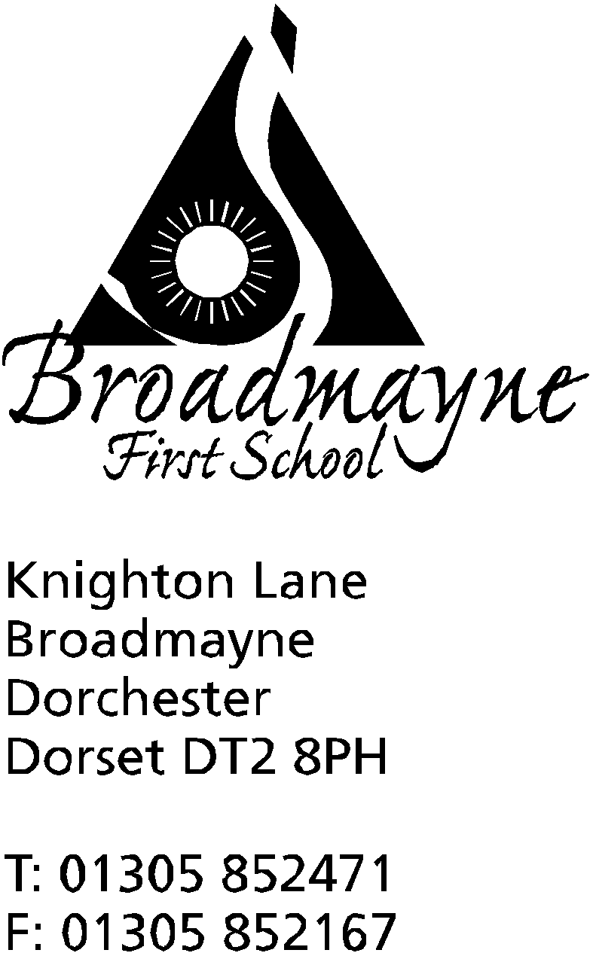

In Dorset

Headteacher
Helen Collings
Thursday 7th February 2019

Spring 2019 - Newsletter 3

Things to remember:
- Number Day is now scheduled for Friday 8th - Learn Alongside your Child will also take place on that morning from 9am
- slips for clubs - STEM will continue after half term, no need to reapply

Dear Parents and Carers,

After a chilly start to February, the weather seems to be settling down again. Hopefully there will be no more snow, but once again, please keep an eye on the school texting service, or the Dorset for You list of school closures if you suspect we may be in danger of closing due to adverse weather conditions. Please ensure children have warm coats to wear at playtimes - children will not be able to go out to play without them.

Number Day
Unfortunately we had to postpone our planned Number Day due to snow. This has now been rescheduled for this coming Friday, the 8th February. Once again, we will be collecting donations for the NSPCC, a charity which has supported our school a great deal. Children can come dressed in anything to do with number - tu-tus, onesies, football kit, or let your imagination run wild! We will also have a Learn Alongside your Child session in the morning, where we invite you to come in and work with your child on a variety of maths activities.

FABS
We have heard that despite the hard work of everyone involved, we were unsuccessful in our bid for the Aviva Community Fund. However, on a positive note, please remember we are one of the three community projects being supported by Co-op this year.The link to our page is: https://membership.coop.co.uk/causes/27176. Once again can I offer the school’s thanks to everyone who who worked towards this, especially Jude Baker.

World Book Day
We will be holding a School World Book Day on Friday 8th March. This is the day after World Book Day is usually celebrated, but will come at the end of a week of activities the school will be holding to celebrate reading and writing, and the love of stories. More details will be sent out in a separate letter, but I thought parents and carers might appreciate a warning that we will be inviting the children to come into school that day dressed up as a character from their own story. The idea behind this is that we don’t want anyone to feel they have to go out and buy a costume for a one off event. Instead we want the children to think up their own character that could appear in a story they make up -and then come dressed as them, ready to tell us all about them!
Cricket
We are pleased to be offering some of our classes the opportunity to take part in cricket lessons in the coming half term. On Thursday 7th March we will be holding an assembly to launch our lessons with All Star Cricket, who will then be working with Reception and Year 1 in the afternoon. For the following 6 weeks Years 2 and 3 will be taking part in Chance to Shine lessons-please make sure that PE kits are in school for this!

CLUBS
All clubs will start the first week back after half term.

STEM Club
STEM Club will continue after half term, on Mondays as previously. There is no need to reapply for this.

Meditation Club
Meditation Club is run by Mrs Simmonds in the library every Wednesday from 3.15 -4pm. Children are welcome to attend on their own, but equally Mrs Simmonds is happy to welcome parents and siblings if they would like to join in too. The club follows the structure of many of the techniques used in the Relax Kids sessions- there will be mindfulness and breathing practice, alongside fun yoga activities.
A donation of £1 is suggested - this can be paid to Mrs Simmonds directly. Please complete the slip below if your child would like to attend.

Football Club
Trevor Senior’s football club will continue on Friday lunchtimes.

Eco Club
Eco Club, run by Miss Felgate and Mrs Bostock, will be on Thursdays from 3.15 -4.15 pm and is offered to children from Years 2,3 and 4.. Children will have the opportunity to take part in a wide range of eco activities, from gardening to Forest Schools. Please complete the slip below if your child would like to attend. There is a cost of £5 per child for this club, to cover resources. Please do not pay this via SchoolMoney, but instead hand it in at the office -thank you.

Lego Club
Lego Club will run on a Thursday from 3.15 - 4.15pm for years R, 1 and 2 with Mrs Bassindale in the Year 1 classroom. if the club is oversubscribed Mrs Bassindale will split the group in half across the term.

Action Van
The Action Van after school club will begin again on Wednesday 27th February. It will run until 4.20pm and is open to all year groups. It costs £2.50 per session - please pay via SchoolMoney.

Yours faithfully

Mrs Collings

------------------------------------------------------------------------------------------------------------------

Yr R, 1 and 2 - Lego Club
I would like my child: …………………………………………. to take part in Lego Club with Mrs Bassindale every Thursday until the Easter holidays from 3.15-4.15pm.

My child will be collected by:...................................................................................................

Signed …………………………………………………………….. Parent/Carer

------------------------------------------------------------------------------------------------------------------
All Years - Meditation Club
I would like my child: …………………………………………. to take part in Meditation Club with Mrs Simmonds every Wednesday from 3.15 - 4pm
- A parent will be attending with my child (please give name)......................................................................
- A sibling will also be attending (please state name(s)) ………………………………………………………...

My child will be collected by:...................................................................................................

Signed …………………………………………………………….. Parent/Carer

------------------------------------------------------------------------------------------------------------------
Yrs 2,3 and 4 - Eco Club
I would like my child: …………………………………………. to take part in Eco Club with Miss Felgate and Mrs Bostock every Thursday from 3.15 - 4.15pm

My child will be collected by:...................................................................................................

Signed …………………………………………………………….. Parent/Carer

______________________________________________________________________________________
All year groups - Action Van

My child would like to attend Action Van after school club

Childs Name & Year Group: ………………………………………………………….

Signed ……………………………………………………………………….. (parent / guardian)

Please print name:......................................................................................

My child will be collected by:

…………………………………………………………………………………………………………………………………

Calendar Dates

Date | Time | Event
FEBRUARY  Thursday 14th |  | Last day of half term
Friday 15th |  | INSET day
Mon 18th- Fri 22nd |  | Half term
Monday 25th |  | Return to School
MARCH  Wk beginning 4th |  | Book Week
Wednesday 6th | 8.50 am | School nurse drop in  YR hearing tests
Friday 8th | 9-9.30 am | School World Book Day -details to follow  Read with a Relative or friend
Mon 11th | 2.45 | Y2 parents SATS meeting
Mon 11th, Tues 12th, Weds 13th | 3.30 - 5.30pm | Parent Consultations
Friday 15th |  | Red Nose Day
Tuesday 19th | 9-10.10 am | Learn Alongside Your Child - focus on spelling and writing
APRIL  Mon 1st, Tues 2nd, Weds 3rd |  | Y4 residential trip to Hooke Court
Thursday 4th | 9.15 am | Year 2 Class Assembly
Friday 5th |  | Last day of Spring Term

