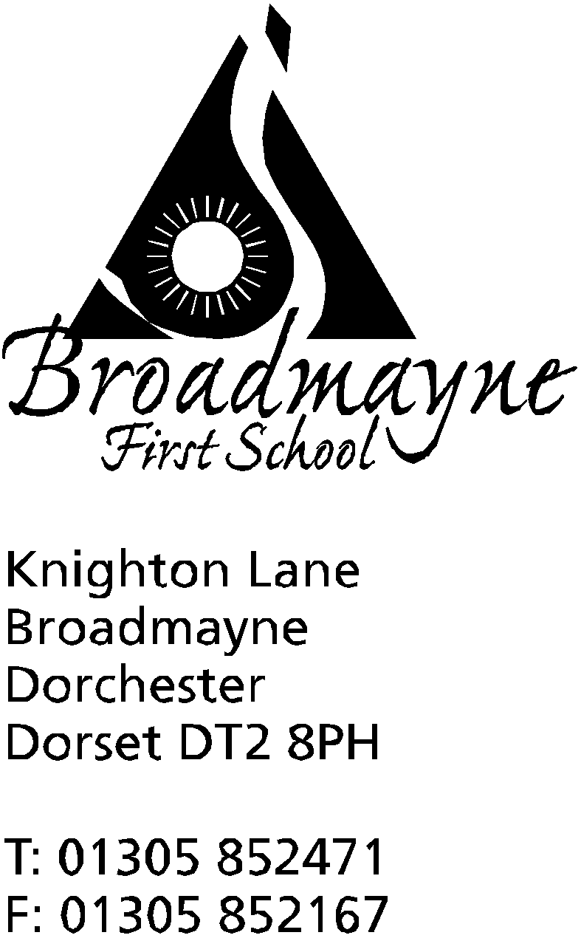

In Dorset

Headteacher
Helen Collings
Monday 23rd March 2020

Dear Parents and Carers,

The school is now functioning as a child care facility for key workers who cannot access child care elsewhere. We are operating a careful staffing structure in an attempt to minimise the spread of any infection, and are using a strict hygiene routine in the school.

School staff will be contacting you at different times, mainly in order to:
- update you with work for your children (this will generally be through Google Classroom and Tapestry, but there will also be links added to the website as time goes by)
- check in with you all to see how you are. Either teachers or TAs will be ringing you all at least once each week - please do respond as we want to know how you are, especially if these measures last longer than expected
- respond to your queries and questions- as a reminder, the email addresses we will be using are:
year_r@broadmayne.dorset.sch.uk
year1@broadmayne.dorset.sch.uk
year2@broadmayne.dorset.sch.uk
year3@broadmayne.dorset.sch.uk
year4@broadmayne.dorset.sch.uk
headteacher@broadmanye.dorset.sch.uk

You can also contact us at the usual office email address. You can use these contacts for enquiries around work, for any concerns you may have, and for help if you are having issues with Tapestry, Google Classroom, or logging on to any of the online platforms we are using.

We are aware that we had planned to send written reports out before the end of term - obviously, events have rather overtaken us - we will plan to send something out after the Easter holidays, although I’m sure you will appreciate that it will not be our usual format. Reception parents, who should have had a parent’s meeting, will receive a short written report as well.

The website has a section for links to organisations to help support yourselves and your children during this time. During a crisis such as this we all need to be mindful of our mental health, and it’s good to think about how we can support this. At school we are following a timetable for the day which looks similar to the one below, and you might find it helpful to follow something similar at home, as it’s well known that following a routine can have a positive impact on our health and well being.

TIME | ACTIVITY
8.30 - 9am | Breakfast, beginning of day
9-10am | Academic time (no electronics)
10-10.30 | Break, snack
10.30 - 12 noon | Creative Time - Lego, art, craft etc
12 - 1pm | Lunch
1- 2pm | Academic time Electronics (TTRS, Spooky Spellings, Numbots etc)
2-3pm | Physical/outdoor activities
3-4pm | Own choice of activity

We will try and keep you updated with what is happening with regards to the school. This is without doubt the worst public crisis in a generation, and our lives are likely to be changed radically for the foreseeable future. We are all thinking of you - we know that for many of our families these will be difficult and troubling times, and we want you to know we are holding you all in our thoughts.

I would like to take a moment to thank all our parents and carers for your support recently. We are all too aware that the future for many of you may be very uncertain. We wish each and every one of you the safest of times and are looking forward to the time when school reopens and we can all reconnect again. Please do reach out to us if there is anything you need, whether great or small - we will be here to support you in any way we can,

Yours faithfully,

Mrs Collings

