This half term the Year 1 topic will be...
In Science we will learn about a range of animal, including fish, amphibians, birds, reptiles and mammals. We will learn the terms omnivore, carnivore and herbivore and what they mean. We will look at animals that live in hot climates and link this to learning already carried out earlier in the year to animals that live in colder climates.
We will use our school environment to support much of this learning e.g., pond dipping and minibeast hunts.
We will continue to practise our skills of prediction and close observation when carrying out investigations.
In English we will continue to practise our phonics daily. We will focus hard on improving our letter formation. We will continue with whole class and guided reading sessions where we will learn about the skills of retrieval and inference with the help of Rex the Retriever and Inference Iggy! Our main text for this topic will be ‘Lila and the Secret of Rain’ by David Conway. We will look closely at the story setting and describe it using adjectives. We will write rain chants and perform them in groups to each other. We will continue to practise using a question mark and an exclamation mark in our writing. We will learn about plurals and practise adding s or es to a noun to make it into a plural. We will also look at the prefix un and what it means eg happy – unhappy.

“Amazing Africa!”

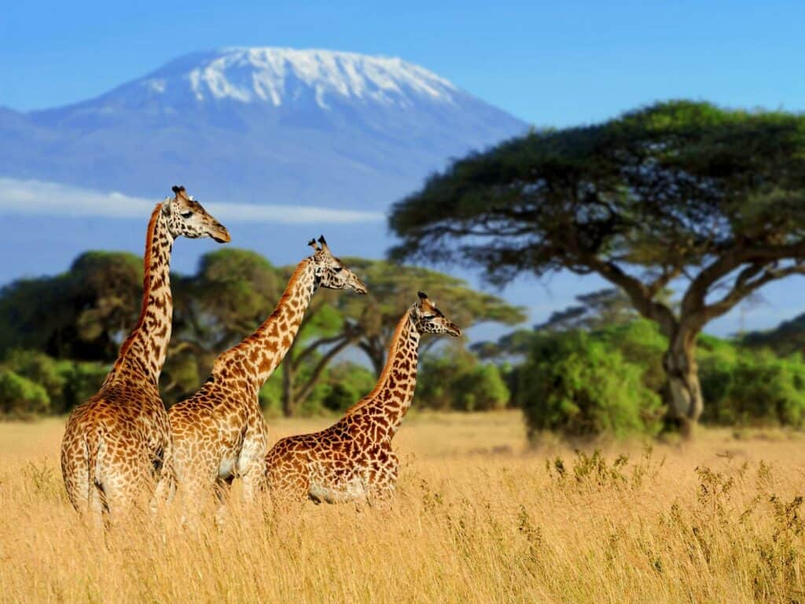

In Maths we will continue to look at addition and subtraction within 20. We will continue to practise counting in 2s, 5s and 10s. We will learn about simple multiplication and division.
We will continue to work on our problem solving, reasoning and fluency skills, focussing on explaining our thinking behind our answer to a calculation. We will use different stem sentences to help us with this.
We will be continuing our measures work looking at capacity and volume using the vocabulary full, empty and half full.
We will then move onto fractions, learning about halves and quarters.

In Art we will be drawing feathers and making sculptural birds.
In DT we will make puppets from fabric.

In ICT we will revisit our programming skills. We will use Scratch Jr to investigate on screen programming and compare this to programming Beebots earlier in the year.
In Music we will listen and respond to a range of classical music e.g., Ravel’s Bolero. We will take part in weekly games to improve our pulse, rhythm and pitch and use percussion instruments to make our own music.

In Geography we will be finding out about life in the village of Mugurameno in Zambia. We find out what it is like to live next to the River Zambezi as well as looking at housing, schools and shopping in Zambia.
In RE we will be learning about the Jewish celebration of ‘Chanukah.’

In PE we will be taking part in swimming sessions on a Wednesday and Friday afternoon. We will learn front paddle and backstroke.
We will also learn a class dance that we will perform during the whole school play at the end of term.
In PSHE we will follow continue to follow our Heartsmart programme with the help of Boris the Robot. Our theme for this half term is “No Way Through Isn’t True!” This theme will focus on teaching the children the importance of perseverance. It will also focus on the subject of change and the feeling associated with this.

