This half term the Year 1 topic will be...
In English we practise our phonics daily. We will take part in both fine motor and gross motor activities to help us with our learning. We will continue to practise our letter formation. Our main text this half term will be Toys in Space by Mini Grey. We will also read a range of other books to support our learning about toys. We will also read individually and in a group each week. We will write labels, lists and captions to go with our pictures. We will use drama to help us with our English learning.

In Science we will learn to name and label the parts of the human body. We will also think about our skeleton and the job it does. We will learn about our senses and use our different senses during welly walks to the woods. We will learn to work scientifically by making observations and drawings and will take part in some investigations.
“Me and My Toys!”

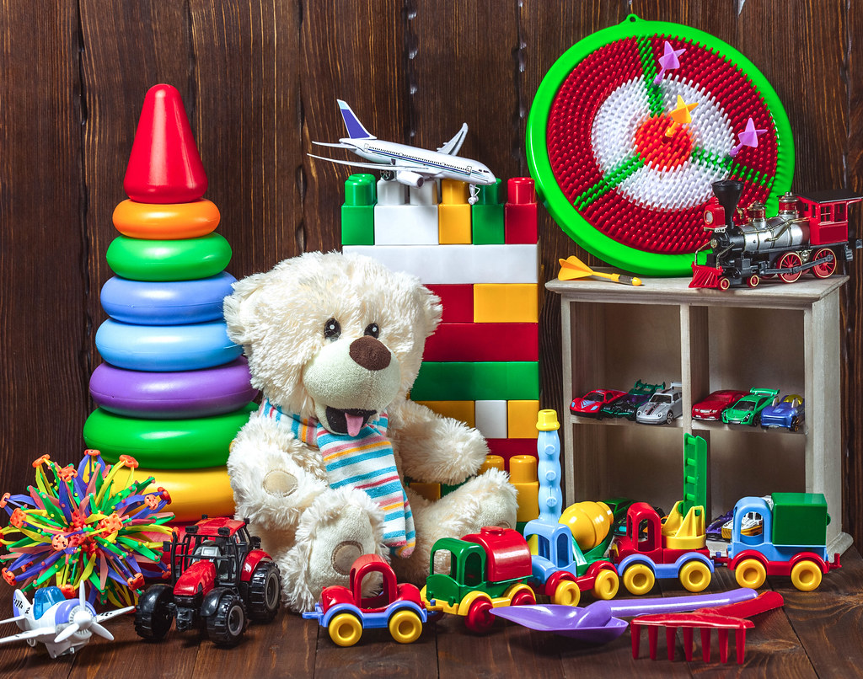

In Maths we will spend time revisiting numbers to 10. We will order and compare numbers and look at place value. We will practise sorting different objects according to their characteristics.
We will continue practising the skill of subitising We will also be practising our number formation so that we can solve problems independently and record our answers.
We will learn how to recognise, name, sort and describe 2D and 3D shapes.
In Art we will be learning to use shapes to create collage pictures and look at the work of Paul Klee. We will paint Paul Klee inspired pictures and portraits.
In ICT we will learn about what the word ‘technology’ means. We will look at how technology can help us in our every day lives. We will then start to become familiar with the main parts of a computer e.g. mouse and keyboard.

In Music we will learn the song ‘Hey You!’ by Joanna Mangona. This song in written in a hip hop style. Alongside this we will play games to help us learn about pitch, rhythm and pulse.

In Geography we will be learning to use our observation skills to carry out fieldwork. We will start with the school and the school grounds. We will have a go at drawing a basic map.
In History we will begin to learn about the present and past and how a timeline can represent this. We will then learn about toys from the past. In RE we will learn about the story of The Creation.
In PE we will be taking part in multi-skill sessions on a Thursday where we will learn to run and jump with control and begin to throw, catch and roll a ball with a partner. On a Friday we will take part in football coaching with Mr Senior.
In PSHE we will follow our Heartsmart programme with the help of Boris the Robot. Our theme for this half term is “Get Heartsmart” This unit will teach us to think about how the choices we make can help or hurt our own hearts and the hearts of those around them.

