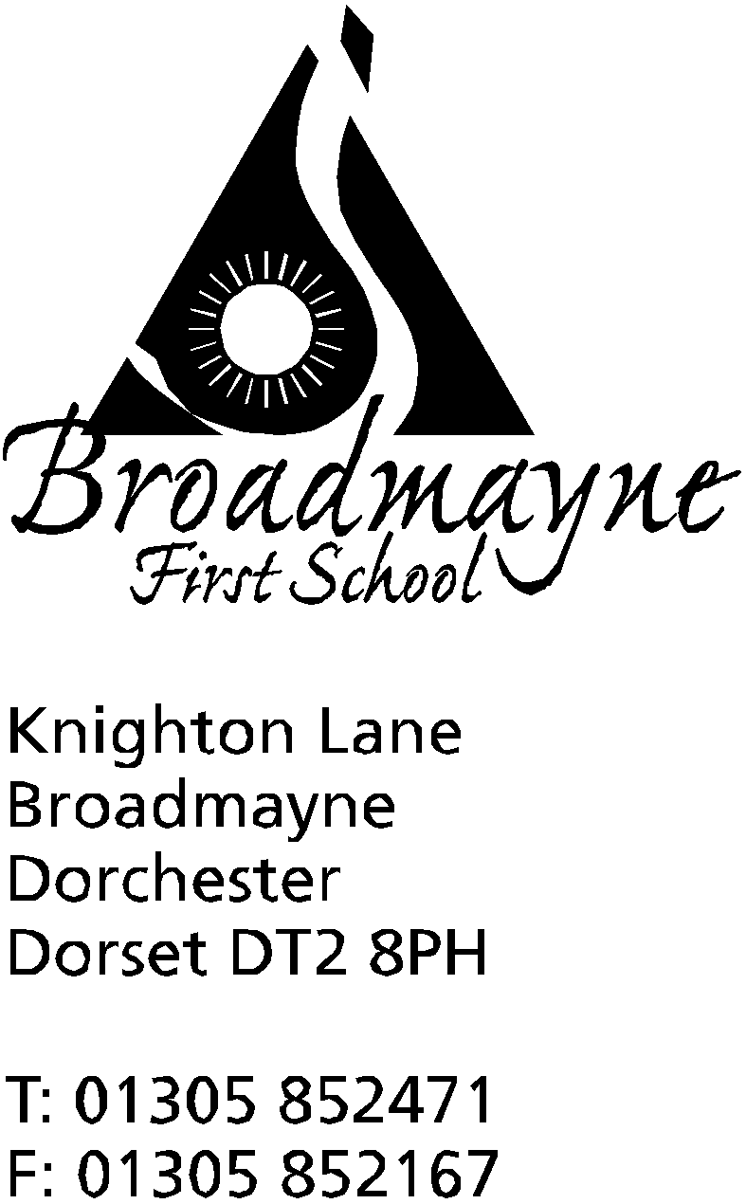

In Dorset

Headteacher
Helen Collings
Thursday 19th March 2020

Dear Parents and Carers,

Following on from my letter yesterday, I am writing to let you know that we have now been instructed to close the school to almost all children after this Friday until further notice. We would like to use this Friday as a day of celebration, and are inviting all children who attend to wear something bright and colourful that they enjoy wearing.
As advised by the government, we will do all that we can to stay open for the children of key workers and children with certain needs.
We are waiting for the government to publish more information on what this means, but it would help us in the meantime if you could let us know if you think you may fall into the category of a key worker and will be requiring childcare from the school. You may do this in one of three ways:
by emailing the school on office@broadmayne.dorset.sch.uk
by telephone on 01305 852471
By filling out the short form which can be found here: https://forms.gle/MnsCAYJzez5b82189

Whichever way you choose please ensure you let us know what your role is, and what organisation you are employed by. We will be in touch again as soon as we are sure who this does apply to.

All other children will need to stay at home, so we ask that you do not send your child into school from Monday onwards. We will re-open fully as soon as we can and will let you know when this is via text and email. Please refer to my letter of yesterday for information on supporting your child’s learning whilst the school is closed. We will not be able to continue with any trips, music lessons, clubs, Breakfast Club, Base Club or Cool Kids while we are closed.

This is as much as we know right now, and we appreciate your continued patience and support as we deal with this ever-changing situation. We understand that this latest news will have an impact on you and your family, and it is far from ideal, but we will continue to keep in touch with any updates as soon as the situation develops.

If you want to get in touch to share any concerns, please don’t hesitate to do so via my new email address, headteacher@broadmayne.dorset.sch.uk

Please remember, do not send your child to school if they or any member of your family exhibit the symptoms of the new virus - please use NHS 111 online for advice.
Yours faithfully,

Mrs Collings

