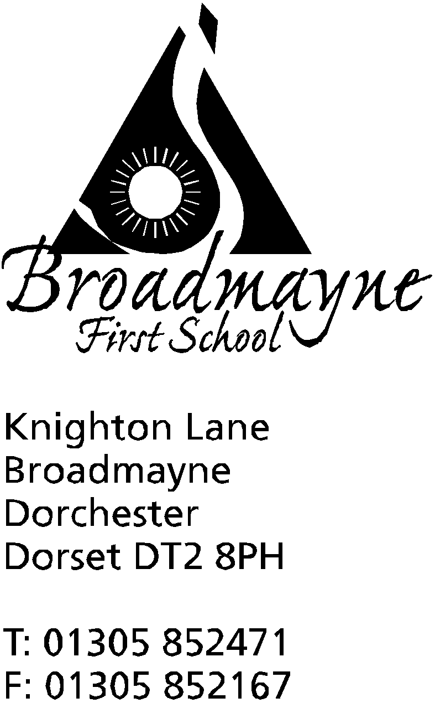

In Dorset

Headteacher
Helen Collings
Tuesday 19th November 2019

Autumn 2019: Newsletter No. 7

Things to remember!
- If you wish your child to have the flu immunisation, have you used the online form to give permission? The deadline is Wednesday 20th.
- The deadline for Reception vision screening opt out is Thursday 21st November, and the screening will take place on Thursday 5th December - a letter went home about this last week. Please ask at the office if you need a duplicate copy.

Dear Parents and Carers,
We have had a busy start to the half term, with the first of our theme weeks, and two classes enjoying recent trips - Year 2 to Safewise where they were able to demonstrate what they had learned during Safe and Healthy Me Week, and Year 3 to Bovington Tank Museum where they extended their learning about WW I.

Poppies and Remembrance Week
Thank you to everyone who bought poppies and bands for Remembrance Week - the school raised £104.73. A big well done to the children in Year 3 who took part in a very moving service at the village war memorial, and to the rest of the school who were quiet and respectful during our observance of the two minute silence.

Children in Need
We had a wonderful ramble in the crisp autumn sunshine to the Wash Pond and back again on Monday. The children (and staff and parents!) enjoyed splashing in the puddles and the mud on the way there, and we all had a paddle before walking back to school. We raised £120 for the charity - many thanks to everyone who contributed!

Christmas Play
As you may know, we have made some changes to the Christmas play this year. Instead of Year 4 leading the play, Year 1 will be taking on the acting roles instead, ably assisted by members of Year 2 as the narrators. The whole school will act as choir for the performances. Year 4 will have their chance to shine in a production we are planning for the end of the summer term.
The Christmas play will be performed in the school hall, and there will be three performances, which are listed on the calendar. We have moved the evening performance to 5pm so it is not too late for the younger children. Please do not worry about costumes for the Year 1 children, as Mrs Bassindale’s mother in law has made a beautiful set which we are all looking forward to seeing being used. More details about performances etc will be shared with you a little later in the term.

Defibrillator Update
Due to the amazing work of Mrs Bassindale, Mrs Bevis, parents and FABS we have now hit our target for buying and installing the defibrillator - well done and thank you to everyone! We are now aiming our fundraising
efforts at ensuring we have a small pot of money available to keep the defib running so we can replace pads
after each use, and to make sure that we can keep the children up to date with first aid training. We are beginning this on Friday of this week, when Chesil First Aid will be coming in to school to deliver first aid training to all classes.
Fundraising will consist of Yr 1 continuing to sell cookies, including a stall at the Christmas Fayre. Thank you to all parents who have helped the Year 1 class to make sure they have extra cookies in addition to those they have baked - they have been very popular!
Staff will also be putting together a food hamper for a raffle, with items they have donated. Tickets will be sold and the draw will take place at the end of the term.

Safe and Healthy Me Week
This was the first of our newly designed ‘theme weeks’ for the school, and what a brilliant start it was! We had a range of visitors coming in, and children in all classes showed fantastic understanding of the topics they studied, whilst also having fun. The learning that took place will be built on across the year - the school have first aid training this week, and we will be visited by the fire brigade early next year, as well as continuing with topics such as E Safety across the year. The week linked closely with our school value of ‘Be Safe’.

Donation from Broadmayne Art Exhibition
Our children recently took part in an art exhibition at the village hall. We are pleased to say that the school has been donated £100 from the exhibition - many thanks to Harry Edwards for organising this. The School Council have decided that the money should be spent on replenishing toys and games for playtimes.

Emergency Closure in the case of Severe weather
With the cold weather approaching, it seems an appropriate time to inform you of our emergency arrangements if severe weather should occur and the school needs to close. Arrangements should the school need to close are as follows:
If you have internet access you can log onto:- http://mapping.dorsetforyou.com/closedservices. Local radio stations are expected to broadcast school closures and display them on their websites although this may take some time. If you do not have Internet access at home, please let us know and we will try to organise an alternative system for notifying you. We will also send out a text message to all parents, if the internet is up and running as our system is web-based. If the weather conditions deteriorate during the school day, we will always endeavour to contact you by text message or phone and the school will remain open until all children are collected. If we cannot contact you and the school needs to be closed urgently, we will, as stated in our admission form, arrange for another parent to look after your child until you can be contacted. Please ensure that the school office has your up to date mobile number and, if you haven’t already supplied this information, the names of parents or relatives who we could ask to collect your children if you are unavailable.
If the school taxi does not run in the morning, the service will be withdrawn for the whole day. For any enquiries about school transport please ring 01305 221704.

Cool Kids
Due to popular demand, the last day for Cool Kids this term will be the last Thursday, the 19th December. Although Cool Kids provides after school care, Miss Barnett and Miss Foster offer a wide range of activities every Thursday from 3.15 pm - 6pm, and all children at school are welcome to come along - bookings can be made via the school office or directly to Cool Kids, and you do not need to commit to come every week. This half term the children will be learning Christmas crafts - starting with pine cone animals this Thursday!

FABS Christmas Fayre
The Christmas Fayre will be taking place on Friday 29th November from 5.30 - 7.30 pm. This year, the FABS
are planning a ‘German Christmas Market’ style event as part of the fayre, but for local produce, and are inviting anyone who would be interested in having a stall selling food or drink products to get in touch via the school office. There will also be the usual exciting range of craft stalls inside, and there are tables available for this as well.

Christmas Letters
Royal Mail have asked us to share the following with you:
At the main Post Office on Dorchester we have a small Santa's Post Box into which children can post their letters to Santa. These are then sent to Santa who will respond to the children if a return address is given.
The letter should be addressed to:
Santa/Father Christmas
Santa’s Grotto
Reindeerland
XM4 5HQ
This is just a little bit of fun to make Christmas extra special for the children. It is best if a 2nd class stamp is put on the letter when it is dropped in the box but this isn't crucial.
For the grown ups, the last posting dates for Christmas can be found on the following link:
https://www.royalmail.com/christmas/last-posting-dates#international-post

Yours faithfully,

Mrs Collings

Date | Time | Event
NOVEMBER
Tuesday 26th |  | Optional flu inoculations
Friday 29th | 5.30pm-7.30pm | Christmas Fair
DECEMBER
Thurs 5th | 9-12 noon | Reception vision screening
Mon 16th | 2pm | Christmas play
Tues 17th | 9.30 am  5.00 pm | Christmas play  “ “
Weds 18th |  | Year 1 trip to the Shire Hall
Fri 20th |  | Last day of term; Christmas party lunch- school finishes at 2.30 pm
Mon 6th Jan 2020 |  | Back to school - First day of Spring Term

