This half term the Year 1 topic will be...
“Poles Apart”

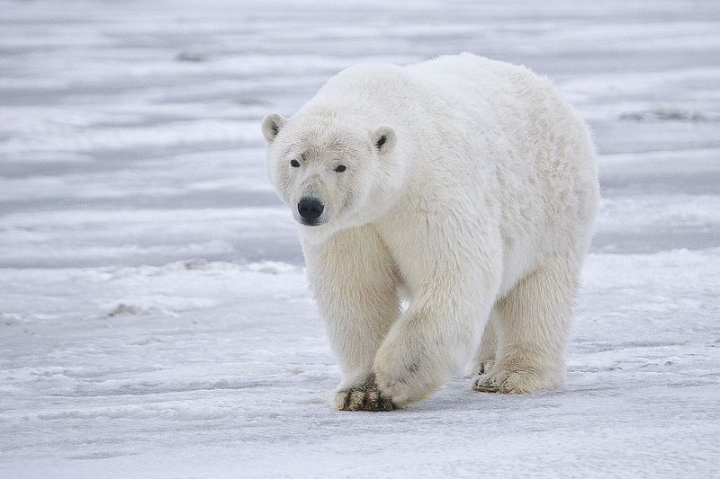

In English we will continue to practise our phonics daily. We will take part in both fine motor and gross motor activities to help us develop our writing pressure and stamina. We will continue to practise our letter formation. Our main text this half term will be Leaf by Sandra Dieckmann. We will also read a range of other books to support our learning about cold climates We will focus on the reading skill of sequencing events with the help of ‘Sequencing Suki!’ We will focus on remembering finger spaces when writing along with a capital letter and full stop to demarcate our sentences.

In Science we will finish learning about our 5 senses and look at how we have changed since we were babies. We will also talk about how to keep ourselves safe and healthy. We will look at changes around us in the seasons. We will continue to learn to work scientifically by making observations and drawings and will take part in some more investigations.

In Maths we will be continuing to practise reading and writing numbers to 10 as words and digits. We will order numbers to 10, learn about ordinal numbers and then move onto addition and subtraction. We will use equipment and pictorial representations to support us with this. Alongside this we will continue to practise the skill of subitising and work on our number bonds.
We will also move on to measuring. Firstly looking at the vocabulary for measuring height and length and then measuring using non-standard units.

In Art we will use pastels to make firework pictures before learning how to mix primary colours to make secondary colours. We will use this skill when sketching and painting Autumn leaves.

In ICT we will learn about digital painting. We will practise using simple tools on a digital painting app to create our own paintings.

Our learning in Music will be based around two songs – Rhythm in the Way We Walk (Reggae style) and Banana Rap (Hip hop style.) We will take part in games based on these songs that support our learning about pulse and rhythm.

In History we will be learning about significant people from beyond living memory, including Guy Fawkes and Moina Michael. In Geography we will be learning about cold climates. In RE we will be learning about why the story of ‘The Nativity’ is so important to Christians.

In PE we will be taking part in multi skills sessions on a Tuesday and practicing our gymnastic skills on a Thursday.
In PSHE we will follow our Heartsmart programme with the help of Boris the Robot. Our theme for this half term is ‘Don’t Forget to Let Love in.’ We will also focus on keeping ourselves safe during ‘Safe and Healthy Me’ week.

