This half term the Year 1 topic will be...
In English we will continue to practise our phonics, spellings, and letter formation. We will continue with whole class and guided reading sessions, where our focus will be learning about the skills of retrieving information (with the help of Rex the Retriever) and talking about the vocabulary used in texts (with the help of Vocabulary Victor) We will be reading poems and non-fiction texts. Our main class text this half term will be ‘The Secret Sky Garden by Linda Sarah. This story is about the themes of growing plants and caring for your environment. We will write instructions on how to plant seeds, write a poem based on the setting of the story and produce a poster to persuade people not to litter. We will continue to learn about basic punctuation and the use of a capital letter for a proper noun. We will introduce ‘and’ as a conjunction.

In Science we will identify and name the main parts of a plant. We will plant some seeds and investigate what a plant needs to grow well. We will learn the names of some different plants and trees and look closely at them. We will carry out some simple investigations to practise our skills of prediction and close observation.
“How does your Garden Grow?”

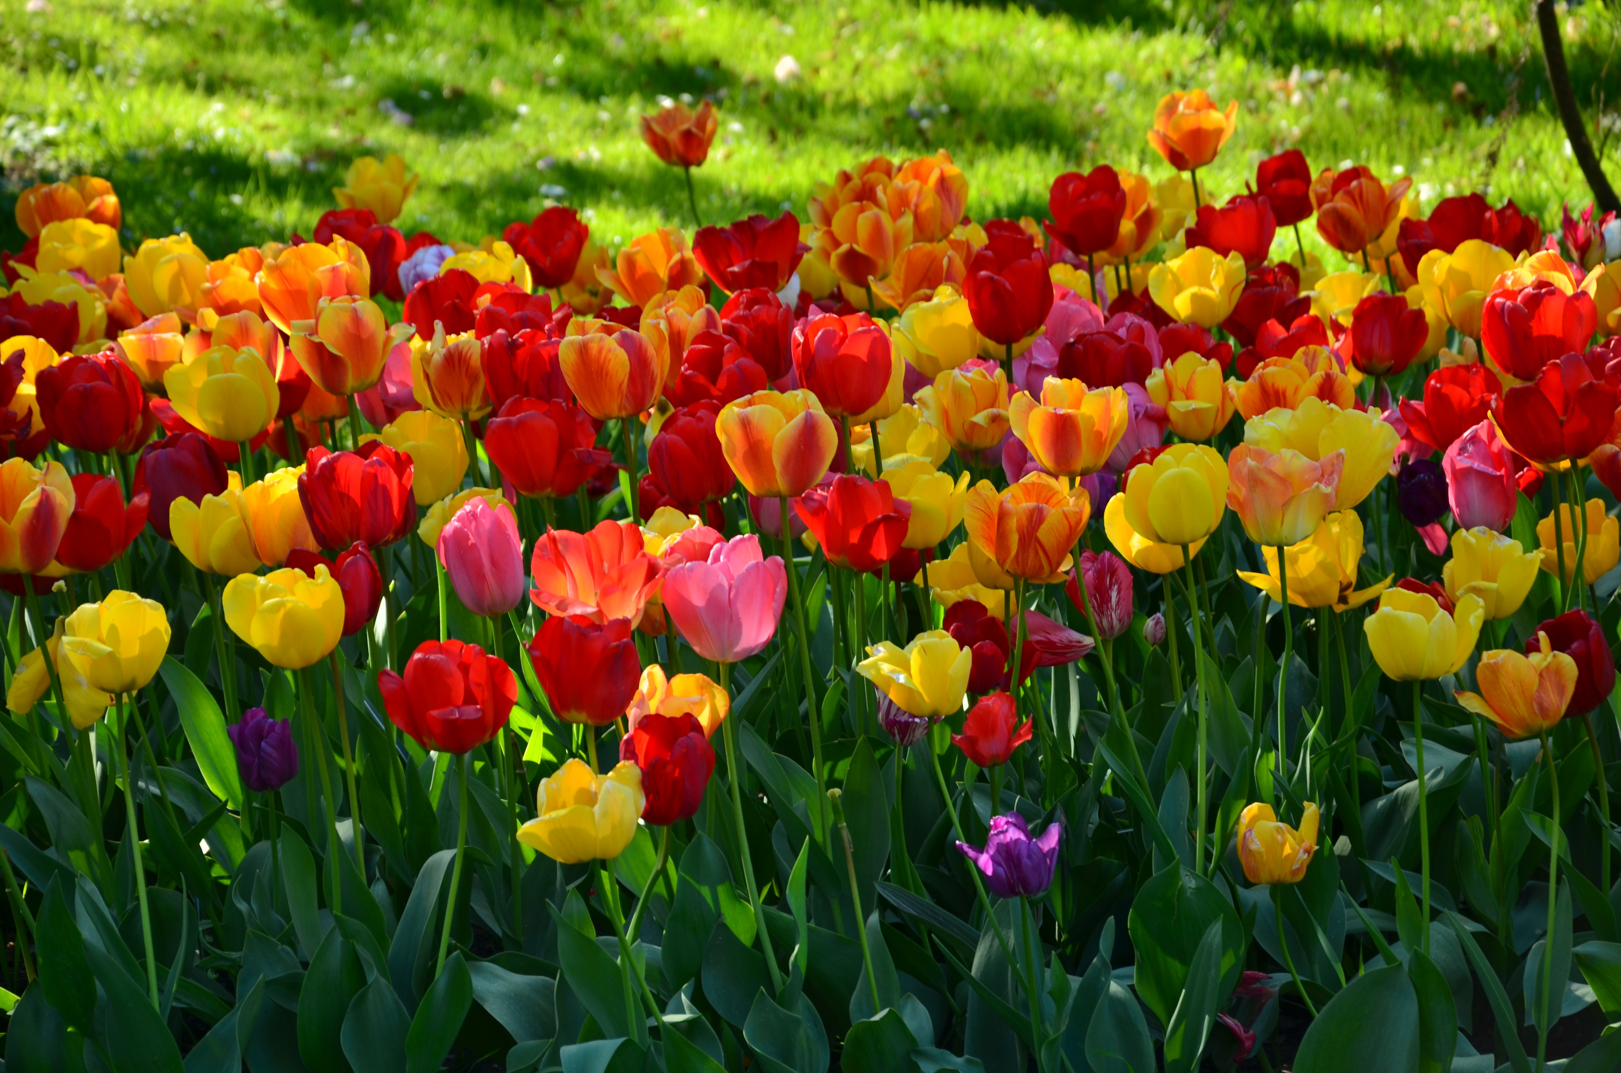

In Maths we will continue to look at the language around addition and subtraction, introduce the subtraction symbol and look at counting back and finding the difference. We will look at tens and ones within numbers to twenty and ordering and comparing numbers to twenty.
We will continue to work on our problem solving, reasoning and fluency skills.
We will also continue with our measurement learning. We will look at measuring capacity before using our knowledge of addition and subtraction to solve problems and reasoning questions involving length, mass, and capacity.
We will then begin learning about fractions.

We will continue our DT learning from before half term by making moon buggies. We will learn how to use a saw to cut wood so that we can make axles with wheels. In Art we will look at drawing spirals and creating spiral snails. We will find out about the work of Henri Matisse.

In ICT we will learn about grouping and labelling objects according to their properties. This learning forms the building blocks for future learning about databases and spreadsheets.
In Music we will listen a range of music from different genres. We will take part in weekly games to improve our understanding of pulse and rhythm.

In Geography we will learn about different types of weather and look at seasonal changes and climate across the world.
In RE we will be answering the question “Was Jesus welcomed like a king or a celebrity by the crowds on Palm Sunday?”

In PE we will be learning basic hockey skills with a coach from Premier Sports. We will take part in simple invasion and defence games. We will also have weekly yoga sessions with a visiting yoga teacher.
In PSHE we will follow continue to follow our Heartsmart programme with the help of Boris the Robot. Our theme for this half term “Don’t Hold on to What’s Wrong!” The children will learn that it is important not to hold on to negative emotions.

