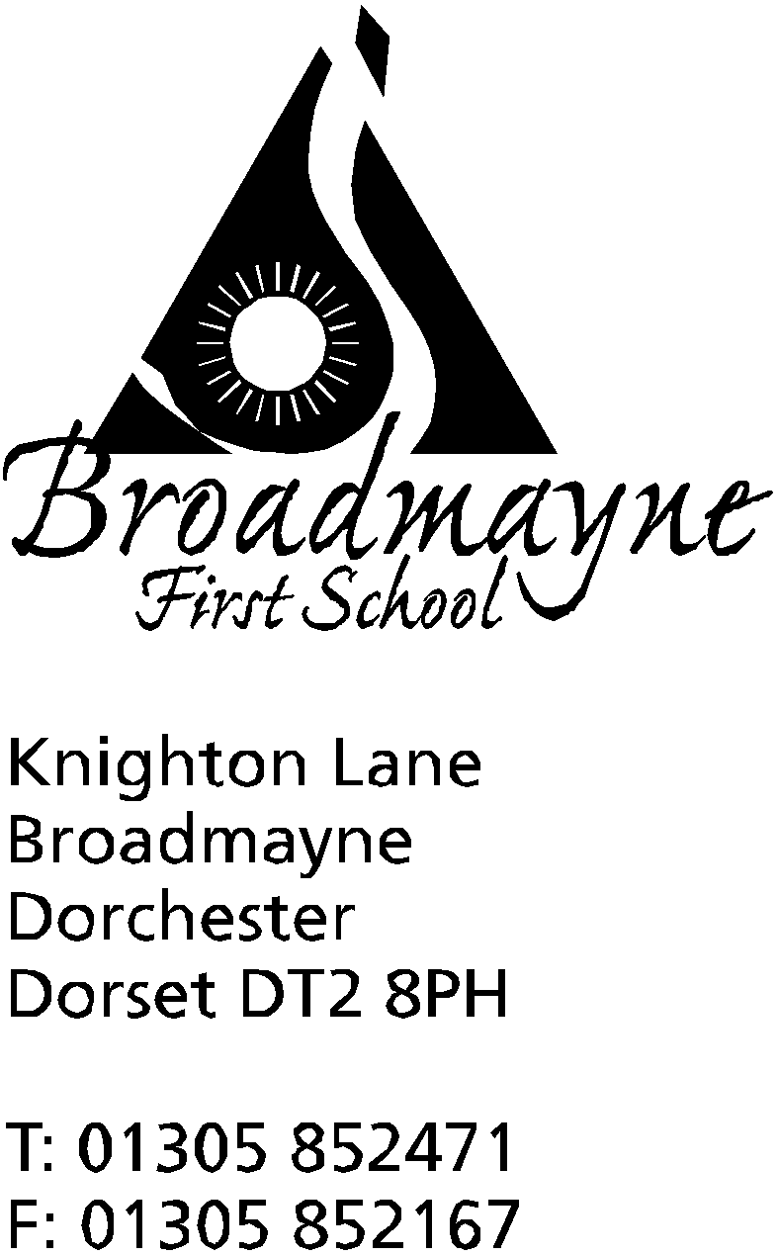

In Dorset

Headteacher
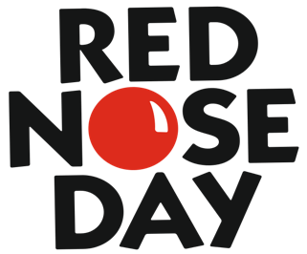
Helen Collings

Monday 4th March 2019

Dear Parents/Carers

On Friday 15th March, we would like to join thousands of people, and organisations across the country, who will be raising money for Comic Relief. The money we raise this Red Nose Day will help people living unimaginably tough lives in the UK and internationally.

Since 2017, Red Nose Day has helped 2.6 million children and vulnerable young adults by funding various charity organisations.

In a recent School Council meeting, we decided we would like to raise money by inviting pupils to wear anything red, in addition to their school uniform, in return for a voluntary cash donation towards Comic Relief. This could include red socks, or a red hairband, a red jumper or t-shirt (instead of school t-shirt). Our pupils are also welcome to wear a Comic Relief red nose or branded deely-boppers if you have them (please initial/name them with a marker). We also thought it would be really fun if each pupil could learn a really good joke to share with their class during the day!
We look forward to having lots of fun on Comic Relief day, while raising money to help others.
Thank you for your support.

Yours sincerely,

Mrs Stoker, Riley, Livia, Faith, Alex, Daisy, Harry M, Tom, Sophie
Broadmayne First School, School Council

