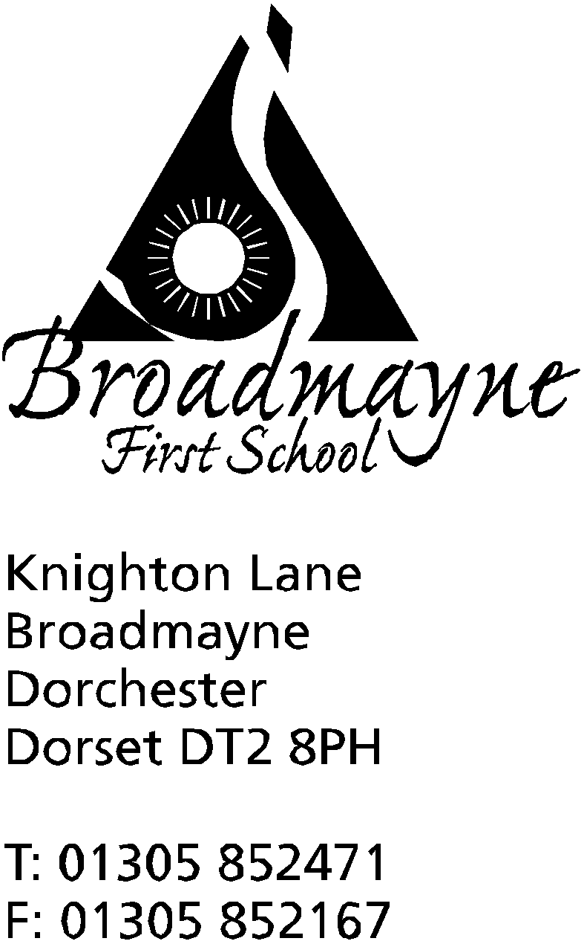

In Dorset

Headteacher
Helen Collings
Monday 4th May2020

Dear Parents and Carers,

As we enter the third week of the summer term, I hope you are all well - we are missing the warm weather here at school, and hoping it makes a reappearance soon!

Whilst I am writing this, we still have no news about the possibility of schools reopening. The Local Authority has informed the government that schools will need at least three weeks' notice before opening, and we hope that this will be the case. As we don’t yet know what form the return will take, I am planning several scenarios, but I would like to reassure you that the wellbeing of our children will be at the forefront of any decisions we make.

I have a few links to share that might be of interest to you over the next few weeks.

One of these is to The Skills Toolkit, which is an online opportunity for adults to upskill themselves with digital and numeracy courses which can be found here: https://theskillstoolkit.campaign.gov.uk/ - it will make a nice change for the adults to be home schooling, rather than the children!

Action for Children are offering online parenting support, including the opportunity to talk to their online coaches confidentially about anything that is worrying you - they can be found here: https://www.parents.actionforchildren.org.uk/covid-19-advice-support

You might want to show your appreciation for the work our staff have been doing over the past few weeks - https://dedicatedteacher.cambridge.org/letateacherknow/?utm_source=SFMC&utm_medium=email&utm_content=https%3a%2f%2fdedicatedteacher.cambridge.org%2fletateacherknow%2f&utm_campaign=EDU+04-20+Teacher+Appreciation+Email+1&WT.mc_id=EDU+04-20+Teacher+Appreciation+Email+1 is a link to the #letateacherknow campaign which gives ideas for pictures and letters your child might like to send to staff (it doesn’t have to be a teacher - I know our TAs have been fab too!)

If you are looking for a short project at home, and your child is interested in making (imaginary!) money, you might want to look at https://www.fiverchallenge.org.uk/fiver-from-home/ which is the Fiver from Home Challenge. This is linked to a project I’d hoped to run in school this term, but will have to leave until a later date, and it encourages children to think creatively around how to start a business with five pounds, including designing a logo and creating a sales pitch - great for any budding Apprentices you might have at home!

Finally, https://www.andersenpress.co.uk/wp-content/uploads/2020/04/STAYING_HOME_medium-res.pdf is a link to a lovely online story about social distancing, and why we are all staying at home at the moment, that you might enjoy sharing with your children.

As you know, this Friday is a bank holiday, moved in order to celebrate 75 years since the first VE day. Sadly all the celebrations that were planned have been postponed, including the community street party we were going to hold here at school, but I know the teachers are sharing some ideas with you as to how you can still commemorate and celebrate this important day at home.

As always, keep well and happy. Once again can I reassure you that we understand it can be tricky to keep on top of the work that is being sent home - please pick and choose what is best for you and your child. Our children have only missed four weeks of school, and there is no expectation that they complete everything- my one request is that you please, please keep them reading as much as possible! At school we are celebrating everything that the children achieve, whatever form that takes, and are looking forward to sharing the children’s experiences once they are back in class.

We look forward to seeing you all soon,

Yours faithfully,

Mrs Collings

