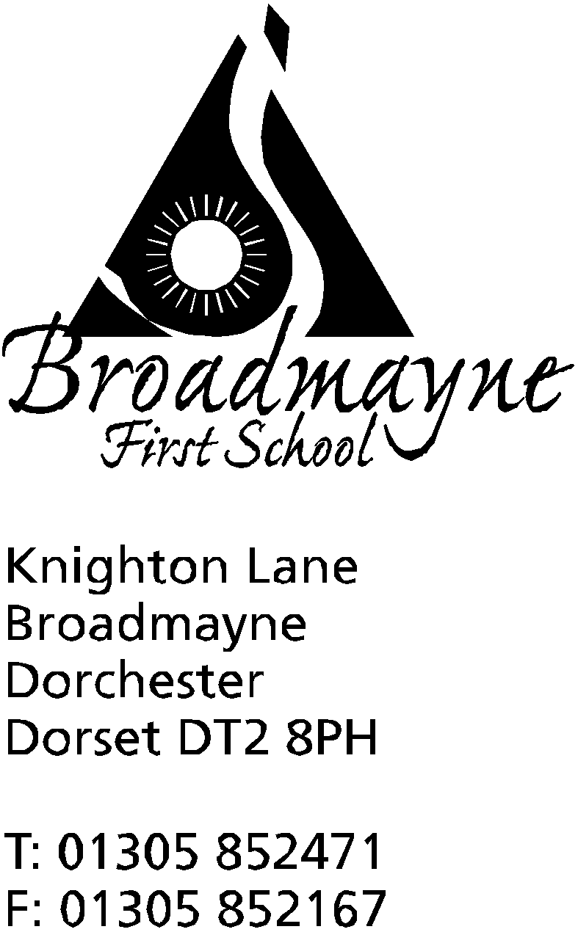

In Dorset

Headteacher
Helen Collings
6th January 2020

Spring 2019 - Newsletter 1

Things to remember:
- Please return slips for clubs as soon as possible.
- Dress Like A Rockstar Day - Monday January 13th

Dear Parents and Carers,

I hope you all had a restful holiday and are looking forward to the new year. There are lots of exciting things planned for the school this term, and new dates for you to note for your diary.

Dress Like A Rockstar Day
In order to start the new year off with a bang, we are planning to Dress Like A Rockstar on Monday 13th January. Everyone is invited to come in to school dressed as a rockstar - be it David Bowie, Brian May, or your own ideas - and bring £1 which will go towards paying for Times Tables Rockstar, a brilliant online support for our children to practise their times tables. All classes will spend the day involved in times tables activities suitable for their age (and maybe some rock star activities too!)

Admission 2020 – Reminder
If you have a child who would be due to start school for the first time or to start middle school in September 2020, the closing date for applications is Tuesday 15th January 2020. It is really important that you submit an application by the closing date for your child to be offered a school place in September. Unfortunately, failure to do so will mean that your child’s application will be considered as late and may reduce your chance of gaining a place at your preferred school.

Emergency Closure in the case of Severe weather
Although the weather has been kind to us so far, I thought it would be a good time to remind everyone of the arrangements should the school need to close at any time:
If you have internet access you can log onto:- http://mapping.dorsetforyou.com/closedservices. Local radio stations are expected to broadcast school closures and display them on their websites although this may take some time. If you do not have Internet access at home, please let us know and we will try to organise an alternative system for notifying you. We will also send out a text message to all parents, if the internet is up and running as our system is web-based. If the weather conditions deteriorate during the school day, we will always endeavour to contact you by text message or phone and the school will remain open until all children are collected. If we cannot contact you and the school needs to be closed urgently, we will, as stated in our admission form, arrange for another parent to look after your child until you can be contacted. Please ensure that the school office has your up to date mobile number and, if you haven’t already supplied this information, the names of parents or relatives who we could ask to collect your children if you are unavailable.
If the school taxi does not run in the morning, the service will be withdrawn for the whole day. For any enquiries about school transport please ring 01305 221704.

Altevette
As you know, our school works to support a girls’ school in Nepal, known as the AlteVette Project. On Saturday 11th January, Mrs Stoker will be packing her rucksack and flying out to Nepal to visit the school. We are looking forward to finding out more about the project, and the lives of the children who attend, and we are keeping our fingers crossed that we will be able to speak to Mrs Stoker once she’s there! We wish Mrs Stoker a safe journey and an interesting and informative trip, and look forward to learning more when she gets home.
If anyone would like to donate any packs of colouring pencils, these would be greatly appreciated - please leave these with the ladies in the office before Thursday 10th.

Reports
This year we are changing the dates on which we send out reports, and as a consequence of this, our next parent consultation evenings will also change. The longer written reports will be sent out at the end of this term, instead of the summer term. We want to trial this change as we feel it will give staff and parents the opportunity to set targets and then to reflect on them in the summer term, during the parent consultations. More information will be sent out nearer the time.

Parent Governor
A vacancy has arisen on our Governing Board for a parent governor. We are looking for parents with the following skills:
• an interest in the performance of the school.
• a desire to contribute to and represent the community
• the ability to look at issues objectively and deal with them confidentially
• a willingness to listen and make informed judgements
• the ability to work well with others
• time to spare - we meet monthly usually on a Tuesday at 5.30pm
• a child or children currently attending the School

As well as attending meetings governors are also asked to look at specific areas of the school’s work in more detail. To help support governors, everyone has access to further training to help build on existing skills or to develop new ones.
At Broadmayne we believe that everyone has something to offer, so if you are interested in any way please contact our Clerk to the Governors, Mrs Sally Foyle, sfoyle@broadmayne.dorset.sch.uk. Depending on the number of applications there may be an election process, which will be advised in due course.

Knowledge Organisers
By the end of this week, new Knowledge Organisers for this half term will be added for each class to the website, here: http://www.broadmayne.dorset.sch.uk/web/knowledge_organisers/430708
As previously, these are designed to provide you and your children with an overview of key facts they will be covering, and can be used to support home learning, as well as being used within school to support learning and recall of topics.

Attendance Meetings
The school is looking closely at attendance this year, and you should have had a report on your child’s attendance as part of the Snapshots that came out at the end of last term. Whilst we fully understand that there are many and varied reasons why a child might not be at school, illness being the most common of these, I will be asking parents whose children have low attendance to come in and speak with me, to discuss the reasons why and see if there is anything the school can do to help support you and your child.

Taster Day - Local Food Links
On Friday 17th January 2020 - there will be a taster day for our hot school meals provider Local Food Links. Children will be able to try a sample of that day’s main meal, alongside their normal packed lunches. The meal for the day is fish fingers and chips. If your child is already signed up for a meal on that day, they may well be able to have an extra portion!

Clubs
The clubs list for this term will be sent out today - please look out for it and return slips as soon as possible, as last term we were oversubscribed in some clubs, and had to cancel another due to low numbers. Please ensure you make a note of what time clubs finish - staff cannot supervise children who are not picked up on time.

Yours faithfully

Mrs Collings

Term Dates for Spring and Summer 2019:

 | Begins | Ends | INSET | Half Term
Spring Term: | Monday 6th Jan | Friday 3rd April | Fri 14th Feb | Mon 17th - Fri 21st Feb
Summer Term: | Monday 20th April | Friday 17th July |  | Mon 25th - Fri 29th May

Calendar Dates- Spring Term
Date | Time | Event
JANUARY
Monday 6th |  | Spring Term begins
Monday 13th |  | Dress Like A Rockstar Day
Friday 17th | AM | Year 4 visit St Mary’s Puddletown for a science lesson
Tuesday 21st | 5.30pm | IPAD Art Day for Years 3 and 4  Full Governing Board meeting
Friday 31st | 1.30 -2.30pm | Year R Dance showcase at St Mary’s, Puddletown
FEBRUARY
Monday 3rd |  | Pantsasaurus visiting the school -start of NSPCC Pants Week
Monday 10th - Friday 14th |  | Collaborative Writing Week
Wednesday 12th |  | Fire Safety team visiting Year R and Year 2
Thursday 13th | 9.15 am | Year 1 Class Assembly  FABS school disco  LAST DAY OF HALF TERM
FrIday 14th |  | INSET DAY
Monday 17th - Friday 21st |  | HALF TERM
Monday 24th |  | Return to school
Tuesday 25th | 5.30pm | Full Governing Board meeting
Thursday 27th | 8.45 am | School nurse drop in  Followed by YR hearing tests
MARCH
Wednesday 4th | 6pm | Year 4 DASP Concert in THS Theatre
Thursday 12th | 9.10 am | Year 3 Class Assembly
Tuesday 24th | 5.30pm | Full Governing Board Meeting
Friday 27th |  | Full written report sent home
Mon 30th - Fri 3rd April |  | STEM Week- Discovery and Exploration
APRIL
Friday 3rd |  | LAST DAY OF TERM  FABS Easter Bingo

