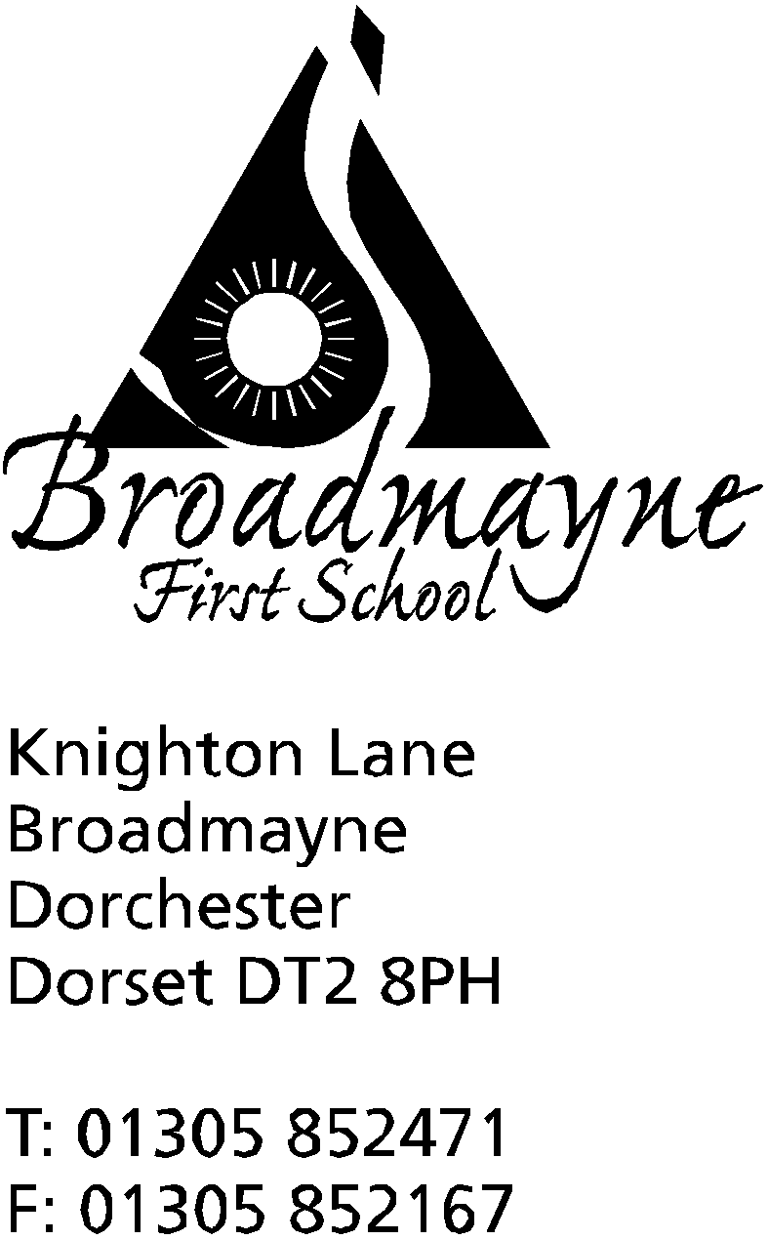

In Dorset

Headteacher
Helen Collings
Tuesday 17th March 2020

Dear Parents and Carers,

I am writing to update you since last night’s announcements from the government with regards to COVID-19. As you may well be aware, the advice has now changed, particularly in regards to the social isolation of vulnerable groups, guidance on which can be found here: https://www.gov.uk/government/topical-events/coronavirus-covid-19-uk-government-response

Please be aware that we have staff who fall into these groups, and they will not be able to come into school for the time being. Please also be aware that we will have to send home any children exhibiting the symptoms associated with COVID-19, and we would ask you to support us with this.

I would like to assure you all that the school continues to work to support our children and the wider community. Currently we are:
- asking visitors not to come in to school
- preventing access to the main school to anyone apart from staff and children
- using hand gel upon entering the school and regularly disinfecting high contact items such as door handles, light switches and keyboards
- postponing assemblies for the time being
- continuing with our work around hygiene with the children
- encouraging children to be outside as much as possible!
- after school clubs have been cancelled, although golf will carry on today and Action Van will take place tomorrow.

Breakfast Club, BASE Club and Cool Kids - These are all currently continuing although they are under review. Parents and Carers must not access the kitchen area or any other part of the school and must wait at the door on dropping off or picking up their children. Hand gel and disinfectant wipes are available at the door.

It would seem that there is a possibility the schools will close in the near future, and I would ask you all to prepare for this. At Broadmayne we will create a ‘virtual’ school via our website, but as I said in my previous letter, we do not expect our families to spend all their time accessing online learning. I am mindful that at times such as these we need to be looking after our mental health most of all, and I hope you all know that everyone in the school wants to support you as much as possible.

These are difficult times for us all, and I would like to thank everyone for their support for the school as we try to find the best way to look after our staff, children and families. If you have any worries or concerns please don’t hesitate to get in touch, and I will try to answer any questions you may have.

Yours faithfully,

Mrs Collings

