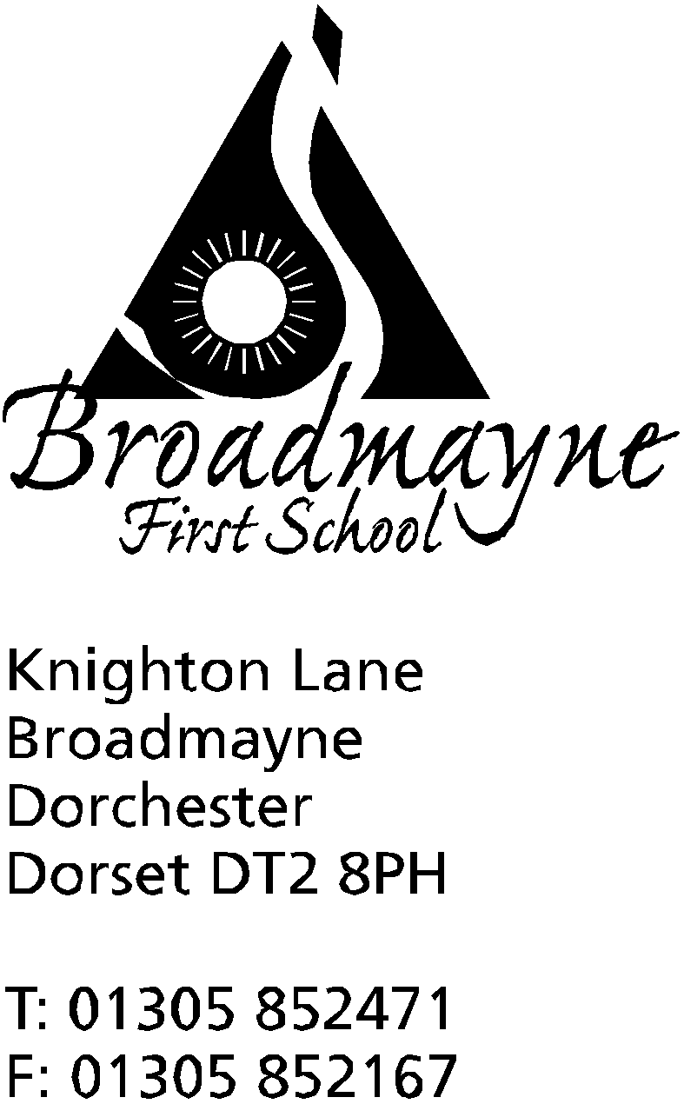

In Dorset

Headteacher
Helen Collings
9th January 2019

Spring 2019 - Newsletter 1

Things to remember: Please return slips for clubs as soon as possible.

Dear Parents and Carers,

I hope you all had a restful holiday and are looking forward to the new year. This newsletter is mainly for the purposes of sharing important dates for the Spring/ Summer terms, and we will share more dates as they are decided upon. Please note a change of date for the Year 4 leavers assembly, which has now moved from Monday 22nd July to Tuesday 23rd, which will be the last day of the school year.

Admission 2019 – Reminder
If you have a child who would be due to start school for the first time or to start middle school in September 2019, the closing date for applications is Tuesday 15th January 2019. It is really important that you submit an application by the closing date for your child to be offered a school place in September. Regrettably, failure to do so will mean that your child’s application will be considered as late and may reduce your chance of gaining a place at one of your preferred schools.

Emergency Closure in the case of Severe weather
This seems an appropriate time to inform you of our emergency arrangements if severe weather should occur. Arrangements should the school need to close are as follows:
If you have internet access you can log onto:- http://mapping.dorsetforyou.com/closedservices. Local radio stations are expected to broadcast school closures and display them on their websites although this may take some time. If you do not have Internet access at home, please let us know and we will try to organise an alternative system for notifying you. We will also send out a text message to all parents, if the internet is up and running as our system is web- based. If the weather conditions deteriorate during the school day, we will always endeavour to contact you by text message or phone and the school will remain open until all children are collected. If we cannot contact you and the school needs to be closed urgently, we will, as stated in our admission form, arrange for another parent to look after your child until you can be contacted. Please ensure that the school office has your up to date mobile number and, if you haven’t already supplied this information, the names of parents or relatives who we could ask to collect your children if you are unavailable.
If the school taxi does not run in the morning, the service will be withdrawn for the whole day. For any enquiries about school transport please ring 01305 221704.

Altevette/Save the Children
The chosen charities for the collection that took place after our nativity performances last term were Save the Children and The Altevette Project, which is the girls’ school in Nepal who we are supporting. I am pleased to say a grand total of £358 was raised, which has been shared equally between the two charities. Linda from Altevette has already been in touch to say how grateful they are for our support, and how impressed she was with how much we raised - many thanks to all who kindly contributed.
Well Being Term
This term we are focusing on well being - of children, staff and the wider community. There will be different activities going on throughout the term to support the well being of our school - more information to follow.
NSPCC PANTS
During the week beginning January 28th, the school will be teaching the children about keeping themselves safe using the NSPCC PANTS resources. These are designed to teach children how to stay safe from abuse, without giving explicit information or telling scary stories. In the lessons children will learn about the PANTS acrostic, which stands for:
Privates are private
Always remember your body belongs to you
No means no
Talk about secrets that upset you
Speak up, someone can help
More information about the underwear rule, including a short video and a parent’s guide, can be found at: nspcc.org.uk/underwearrule
Daily Mile
The children in school have been running, walking and skipping their way to a healthy break in the school day with the Daily Mile. Since introducing it in October, the school has run a distant equivalent to travelling from Broadmayne to Warsaw in Poland! We are looking forward to seeing how far we can travel this term.
Parent consultations
This term we’ll be inviting you to individual Parent Consultations on Monday 11th, Tues 12th and Wed 13th March from 3.30-5.30. More details will be sent out nearer the time but if you would like to discuss your child’s progress or any concerns at any other time, please contact teachers directly or through the school office.
Club update- please complete slips and return by Friday 11th
STEM CLUB (Science and Technology) for Years 3 and 4 with Mrs Stoker will run on the following dates:
Spring 1 Spring 2
· Week 1 – Monday 14th January Week 1 - Monday 4th March
· Week 2 – Monday 21st January Week 2 - Monday 11th March
· Week 3 – Monday 28th January Week 3- Monday 18th March
· Week 4 – Monday 4th February Week 4 - Monday 25th March
· Week 5 – Monday 11th February Week 5 - Monday 1st April
The club will be from 3.15 - 4.15pm, pick up from Reception door. The cost for this club will be £5 per child - please do not pay this through School Money but instead hand into the school office, cash only and the correct amount would be appreciated, as we do not have change. The club will be aiming to achieve a national science award and so numbers are limited.
DANCE CLUB for Years 3 and 4 with Mrs Howells.This will run every Monday beginning the 14th January until half term, from 3.15 to 4pm. It is free to join.
LEGO CLUB for Years R, 1 and 2 with Mrs Bassindale. This will run every Thursday until half term from 3.15 – 4.15 pm and is free to attend.

There will be other clubs running after half term including an Eco Adventure Club for Yrs 1 and 2, and Action Van-more details to follow. Existing lunchtime clubs will continue.
Yours faithfully

Mrs Collings

Term Dates for Spring and Summer 2019:
Spring Term 1st half term Monday 7th January - Thursday 14th February
Friday 15th February INSET
Half term break Monday 18th February - Friday 22nd February
2nd half term Monday 25th February - Friday 5th April
Summer Term 1st half term Tuesday 23rd April - Thursday 23rd May
Friday 24th May INSET
2nd half term Monday June 3rd - Tuesday 23rd July

PERMISSION SLIPS FOR CLUBS
------------------------------------------------------------------------------------------------------------------
Y3 & Y4
I would like my child: ……………………………………………….. to take part in STEM Club with Mrs Stoker.
Mondays 3.15 - 4.15 pm

My child will be collected by:.....................................................................................
I enclose £5 to cover costs (please do not pay via School Money)

Signed …………………………………………………………… Parent/Carer

------------------------------------------------------------------------------------------------------------------
Y3 & Y4
I would like my child: …………………………………………. to take part in Dance Club with Mrs. Howells every Monday until half term from 3.15-4pm.

My child will be collected by:...................................................................................................

Signed …………………………………………………………….. Parent/Carer

------------------------------------------------------------------------------------------------------------------
Yr, 1 and 2
I would like my child: …………………………………………. to take part in Lego Club with Mrs Bassindale every Thursday until half term from 3.15-4.15pm.

My child will be collected by:...................................................................................................

Signed …………………………………………………………….. Parent/Carer

B

Calendar Dates

Date | Time | Event
JANUARY  Tuesday 15th | 5.30pm | Full Governors Meeting
Wednesday 16th | 8.50 am | School Nurse drop in -no appointment necessary  YR Heights and Weights.
Thursday 17th | 9.15 am | Year 1 Class Assembly
Wednesday 30th | 8.15 am | Finance Governors Meeting
FEBRUARY  Friday 1st | 9 - 10.10am | NSPCC Number day  Learn Alongside Your Child -maths focus
Tuesday 5th |  | Safer Internet Day
Wednesday 6th | 1.45 pm | Pantomime performance in school
Thursday 14th |  | Last day of half term
Friday 15th |  | INSET day
Mon 18th- Fri 22nd |  | Half term
Monday 25th |  | Return to School
MARCH  Wk beginning 4th |  | Book Week
Wednesday 6th | 8.50 am | School nurse drop in  YR hearing tests
Friday 8th | 9-9.30 am | School World Book Day -details to follow  Read with a Relative or friend
Mon 11th | 2.45 | Y2 parents SATS meeting
Mon 11th, Tues 12th, Weds 13th | 3.30 - 5.30pm | Parent Consultations
Friday 15th |  | Red Nose Day
Tuesday 19th | 9-10.10 am | Learn Alongside Your Child - focus on spelling and writing
APRIL  Mon 1st, Tues 2nd, Weds 3rd |  | Y4 residential trip to Hooke Court
Thursday 4th | 9.15 am | Year 2 Class Assembly
Friday 5th |  | Last day of Spring Term

