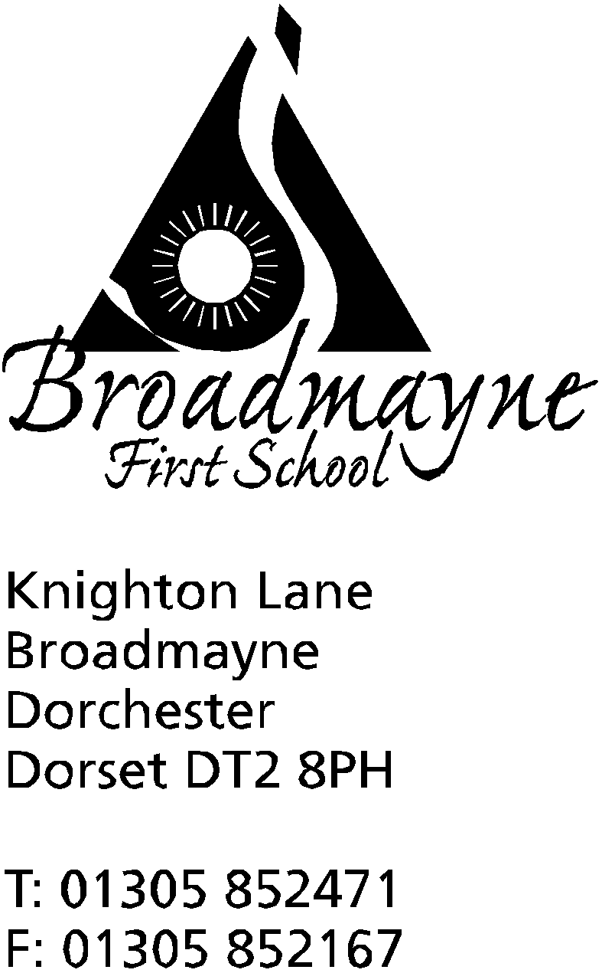

In Dorset

Headteacher
Helen Collings

Broadmayne First School - Science Week – 11th – 17th March 2019

Monday 4th March 2019
Dear Parents/Carers,
Thank you so much for your support with the school fundraising event last week. We were delighted to submit our application to Primary Science Quality Mark with your support and backing from FaBS.

At Broadmayne First School, we are always working on new ways to enrich our curriculum; making the learning in our school memorable, exciting and interactive. On 11th – 17th March, we are busy planning Science Week which will be themed ‘Journey into Space’, as this year marks the 50th anniversary of the first landing on the moon via Apollo 11.

We have organised for several Science specialists to visit School during the week, and a Rocket Show booked on Thursday 14th March for all pupils. We also have class-based workshops planned during the week, as we investigate ‘space’.

We would like to ask you for a voluntary contribution of £2 per family to help cover the costs of the activities we have planned. This can be paid via School Money - please do not send money into school. We really appreciate all your help, and we try hard to keep costs to a minimum.

On the reverse of this letter are details about a Poster Competition being run by the British Science Week Organisation. If your child would like to enter, please fill in the online registration and then post it to the address overleaf. We’d love to see copies of your entries!

We look forward to a fantastic and memorable week of Science. For families with children in Acorn and Chestnut classes, pictures of these activities will be available on Tapestry. We will also have pictures of our fun-filled activities on our school website for you all to share with your children.

Thank you for your support.
Yours sincerely,

Joanna Stoker
KS1 Science Co ordinator

