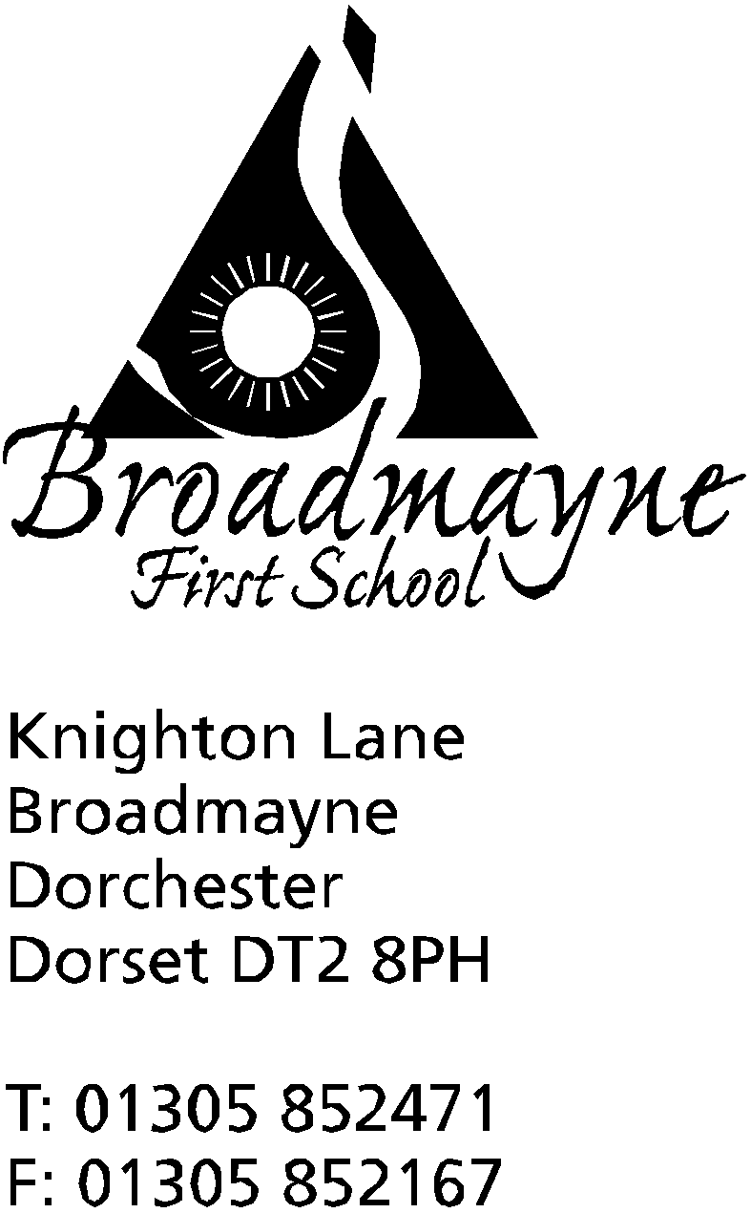

In Dorset

Headteacher
Helen Collings

Tuesday 25th February 2020
Spring 2020 - Newsletter 5

Things to remember:
- Years 3 & 4: Have you returned your photo permission form for Kingston Maurward?
- Dance Club will continue for existing members for the following sessions: 2/3/20 9/3/20 plus one other TBA

Dear Parents and Carers,
We would like to welcome you all back to school after a somewhat blustery and wet half term break! All our fingers are crossed that the weather will start to take a turn for the better through this half term, although we are mindful that the ‘Beast for the East’ arrived at the beginning of March two years ago!

Fair Trade Cafe
Our annual Fair Trade Cafe is running this week. Each class will have the opportunity to l be able to have a snack and a drink prepared by our Year 3 children using all Fairtrade ingredients. In order to support the cafe, we are asking for a donation of £1.50 per child, payable through School Money - this is to cover the cost of ingredients.

Clubs
Clubs will continue as per the timetables shared at the beginning of term. Please note however that Action Van was not running last half term but will begin this Wednesday, the 26th February. If you have not already signed your child up, please do so via School Money before all places are taken. The club runs on Wednesdays until 4.20pm, and enables children from Reception to Year 4 to take part in a wide variety of sports activities, including archery and basketball.

Dorchester Science Festival
Further to the information in the previous newsletter about the Family Science Fair on the 15th March, we would also like to draw your attention to the following events which will be taking place as part of the festival:
Kitchen Science Experiments
Saturday 14th March 2pm- 3:30pm
Waterstones Book Shop
Suitable for ages 7+
Come along and take part in exciting kitchen science experiments. No booking necessary!
Science at the Dorchester Library
Saturday 7th March
14:30- STEM and Lego activities (age 4+)
Free of charge

British Science Week (6th - 15th March 2020)
To celebrate British Science Week, we would like to invite pupils to take part in a 'Science Selfie Challenge'. We would like to see photos of you taking part in science related activities at home and tell us why this is 'Super Science'. This could be exploring magnetic surfaces around your home, testing gravity with different objects, planting seeds, facts about your favourite animals etc-we'd love to see what fun activities you get up to! Please print off the attached template and add your selfie (photo or drawing) and a description of what you are doing or have learnt.

We'd also like to draw your attention to a fantastic resource we use in school called Explorify, which is free to join! This is a brilliant website which encourages science discussions with children. Take a look! Activities we recommend are 'Odd One Out', and 'Zoom In, Zoom Out.' We'd love to hear about your Explorify conversations! Please let us know if you try an activity, by drawing pictures or write down your ideas, and bring them into school for the attention of Mrs Stoker, our Science Coordinator.

We'd also love to hear from any parents who have STEM related jobs to come in and talk to our pupils about the passion you have for your area of expertise. Please contact the office if you are interested in visiting our school to inspire the next generation of scientists

Yours faithfully,

Mrs Collings

Calendar Dates- Spring Term
Date | Time | Event
FEBRUARY
Tues 25th - Fri 28th |  | Fair Trade cafe
Tuesday 25th | 5.30pm | Full Governing Body meeting
Thursday 27th | 8.45am  2.45pm | School Nurse drop in followed by YR hearing tests  Hooke Court Meeting for parents
MARCH
Tuesday 3rd | 5pm | Hooke Court meeting for parents
Wednesday 4th | 6pm | Year 4 DASP Concert at THS Theatre
Thursday 5th |  | World Book Day - details to follow
Mon 9th - Fri 13th |  | Sports Relief Week
Thursday 12th | 9.10am | Year 3 Assembly
Mon 23rd and Tues 24th | 3.30 - 5.30pm | YR parents consultations
Tuesday 24th | 5.30pm | Full Governing Body meeting
Friday 27th |  | Written reports sent home
Mon 30th - Fri 3rd |  | STEM WEEK - Exploration and Discovery
APRIL
Wednesday 1st | 9.10am | Year 2 Class Assembly
Thursday 2nd |  | YR trip to THS for a Rocket Workshop
Friday 3rd |  | FABS Easter Egg Bingo  BREAK UP FOR EASTER HOLIDAYS
Monday 20th |  | Return to school

