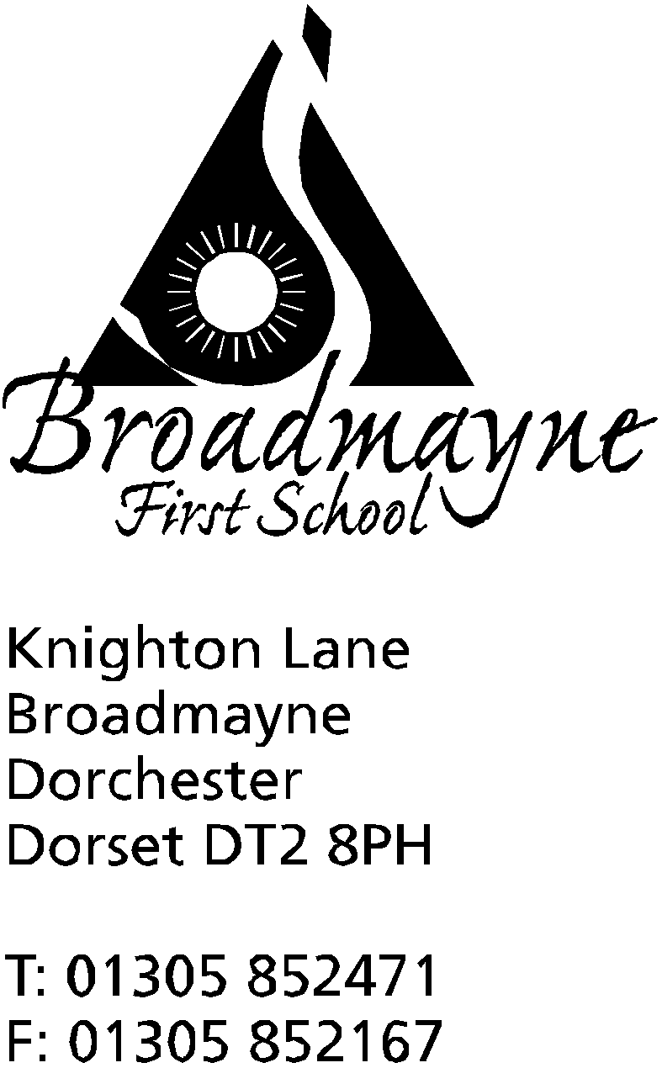

In Dorset

Headteacher
Helen Collings
Friday 29th March 2019

Spring 2019 - Newsletter 7

Things to remember:
- We come back to school on Tuesday 23rd April - after Easter Monday
- Non school uniform Friday 5th April -bring an Easter egg!

Dear Parents and Carers,

It feels as if Spring might finally be here - the bluebells are beginning to make an appearance in the woods, and we are all enjoying the opportunity to take some of our learning outside. Staff have asked me to remind you to send children in to school wearing coats, as it is still quite chilly outside, despite the welcome appearance of the sun!

Home Learning
We are currently reviewing our approach to Home Learning, and are keen to find out parents’ views about what we currently offer, and our focus for the future. To that end, we are sending out a questionnaire to parents. This is a Google Forms questionnaire - the link can be found here: https://goo.gl/oDVmxo The data is anonymous unless you wish to include your name. A paper copy will also be sent out to those families that have paper copies of this newsletter. We need as much feedback as possible to help inform our next steps, so please take the time to fill in the form and send it back to us.

FABs
The FABS held a very successful, and entertaining, barn dance last Friday at the village hall. It was lovely to see so many parents, children and local villagers coming along and taking part in the dances, some of which were quite challenging! The FABS raised £360, which will be used to help purchase a subscription to The Power of Reading, a programme to help raise children’s engagement and attainment in reading and writing.

Non School Uniform Day
On Friday 5th April we will be holding a non school uniform day. As in previous years, we would like the children to bring an Easter egg or similar in return for not wearing their school uniform for the day. I have it on good authority that there may be a visit at some point by the Easter Bunny, accompanied by her close personal friend, the Easter Chick!

Parking
We have recently had some concerns expressed to us by staff and parents around parking, particularly at the beginning of the school day. If you drive a larger vehicle, please be aware that if you reverse into the spaces outside school, your bumper comes quite far across the pavement, which is a safety concern for children walking in to school, and can make it difficult for people with pushchairs to pass by. Please be mindful of this when parking.
Could I remind everyone that the school car park cannot be used as a walkway into school, and the designated path must be used. It is also not available for parents to use to park in when dropping off or picking up children - it is only for staff, visitors to school and disabled use. Many thanks for your help with this.

Attendance
With the Summer term approaching I am beginning to receive holiday request forms from parents. Please remember that, in accordance with other schools in the Dorchester area, we do not normally give permission for term time absence, unless in exceptional circumstances, and even then we would not expect to agree to more than 5 days absence. The school is working hard to improve its attendance figures, and we hope that you will support us with this. The snapshots that will be coming out next week will now have an attendance figure on them so you do not have to wait until the end of year report to know what your child’s attendance has been - hopefully you will find this information useful.

Staffing Update
As you know Mrs Denning will be retiring at the end of next week and we are all very sad to say goodbye to her. We have appointed her replacement and we are pleased to welcome Mrs Kerry Watts to the school. She will be the new face in the office from the beginning of the summer term; please bear with us whilst training is in progress!

Sandworld Family Tickets
Coming home with your child today will be a complementary family ticket for Sandworld in Weymouth. for their Grand Opening on the 6th April. Each year a local school is chosen to be the first to see their exhibition of sand sculptures, and this year they have chosen Broadmayne (thank you to Jess Richardson for arranging this!) The line up this year includes a ‘Back to the 80s’ section, including Back to the Future, Ghostbusters and ET. Other visiting artists have sculpted Toy Story, Marvel, and a host of other sculptures, including a ‘Here Come the Girls’ featuring Moana and Elsa. Your ticket also allows you to play and create your own mini masterpiece in the sand, with help from the staff. The venue is also dog friendly. Please check for the ticket - we will be sending it home with your oldest child if you have more than one child at the school!

We wish you all a happy and relaxing Easter holiday, and look forward to seeing you back at school on on Tuesday 23rd April.

Yours faithfully,

Mrs Collings

