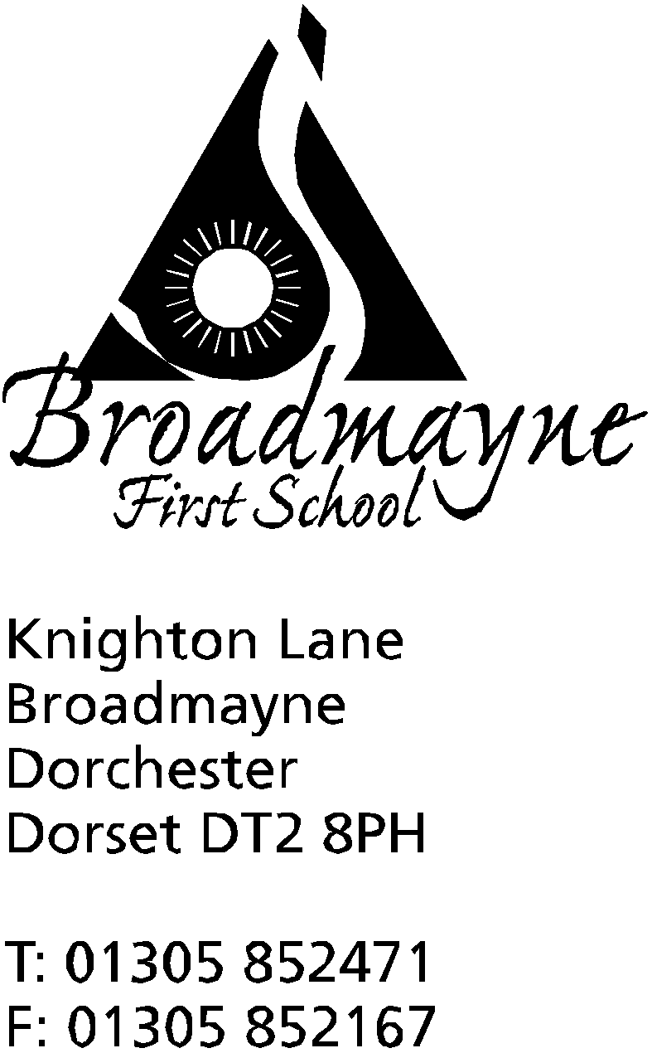

In Dorset

Headteacher
Helen Collings

Wednesday 4th March 2020
Spring 2020 - Newsletter 6

Things to remember:
- Come dressed in your pyjamas with your favourite bedtime story on Thursday!
- Read with a Friend or Relative on Thursday at 2.30pm
- Year 4 concert this evening at THS theatre

Dear Parents and Carers,

The newsletter this week is to let you know some updates from the Department for Education and to remind everyone of some of the things that will be happening over the next few days. Please don’t forget the Year 4 concert in the Thomas Hardye School theatre this evening - children need to arrive at 6pm for a 6.30pm start. This is always a wonderful, uplifting event, and every child’s voice counts!

Books at Bedtime
We had a wonderful turn out of parents, grandparents, carers and children for our annual Books at Bedtime yesterday evening. Staff and children dressed in pyjamas and dressing gowns, and enjoyed sharing stories together, followed by hot chocolate and biscuits. A huge thank you to everyone who came along, and to our lovely FABS who manned the tea and hot chocolate making.

Snacks at school
We have had some issues with children bringing their snacks into school in their lunchboxes, and then forgetting to take them out at the beginning of the day. As it is a school rule that lunch boxes are kept in the kitchen until lunchtime, this means that it is difficult to access them at break time. Please can we ask that children bring snacks in separately to their lunchbox - preferably in a named pot or tub. This then avoids the issue of children having to remember to remove their snacks before putting their lunchboxes away. Each class has a tray or basket to keep snacks in. As a reminder we have a healthy snack policy at break times - fruit and vegetables preferably - and are a nut free school.

COVID-19 (Coronavirus)
This week we will be holding a whole school assembly and class discussions around ‘health hygiene’ and the importance of good hand washing. This is in response to the current levels of concern around the COVID-19 coronavirus, although as we are saying to the children, good hand washing routines should be practised at all times! We will mention the coronavirus when speaking with the children, as many of them have heard of it, but in a context that seeks to reassure and support them. The school continues to follow Department for Education and Public Health England guidelines.
The DfE have launched a new helpline to answer questions about COVID-19 related to education. Staff, parents and young people can contact the helpline as follows:

Phone: 0800 046 8687
Email: DfE.coronavirushelpline@education.gov.uk
Opening hours: 8am to 6pm (Monday to Friday)

Outdoor Play Area
Later this week you should see some activity taking place around our outdoor play area. The clamber stack was the first new installation, and now thanks to funding from the WPA Benevolent Foundation and the National Lottery, the final two structures are being put in place. This consists of a 5 metre traverse wall and an outdoor gym area. We are looking forward to seeing our children make full use of these as the weather improves - fingers crossed for some dry days so they will be able to get outside and really make the most of this fantastic new equipment!

Dorchester Cricket Club
Spring is nearly here and Dorchester Cricket Club are excited to present All Stars Cricket for 5 to 8 yr old boys & girls again in 2020 for all children at Broadmayne School from Reception to Year 3/4.
The first session is on Saturday May 16th @ Dorchester Recreation Ground from 0930 till 1130 and every Saturday thereafter for 8 weeks.
Dorchester are also running the exciting new Dynamos cricket for yrs 4 to 6 straight afterwards from 11 to 12.
Registering online is easy and starts from the 19th February, just visit the All Stars / Dynamos website and type in Dorchester CC in the toolbar and complete the registration in a couple of minutes.
As part of the initiative all children will receive a backpack, bat , ball, water bottle, cap and a shirt with his/her name! Sessions will focus on being fun & active, and developing each child's movement & skills.
Dorchester CC have the very best facilities in the area and the highest qualified Level 3 accredited coaches in the county, who are all safeguarding registered. Out of hundreds of clubs involved in this last year Dorchester CC were proud to be in the top 5 in the country, and 2020 looks to be even better with an already established set up.
After the 8 week course finishes sessions will continue throughout the summer at a charge of just £1 per child per session!
Please contact Simon Joslin on 01305 262850 if you require any further info.

FABS
The FABS have been busy fundraising, and so far this term have raised the following:
Calendars £262
Disco £200
Y1 Bake Sales £170
Total £632
Thank you so much to everyone for their continued hard work and support. There will be Easter Bingo later in the term, and we are hoping to begin work on the Year 1 classroom refurbishment at Easter.

Yours faithfully,

Mrs Collings

Calendar Dates- Spring Term
Date | Time | Event
MARCH
Wednesday 4th | 6pm | Year 4 DASP Concert at THS Theatre
Thursday 5th | 2.30pm | World Book Day - come dressed in your PJs!  Read with a Friend or Relative
Mon 9th - Fri 13th |  | Sports Relief Week Details in separate letter - come dressed as a sport’s star on the Monday!
Thursday 12th | 9.10am | Year 3 Assembly
Monday 16th | 2.30pm | Year 2 parents and carers SATS meeting
Mon 23rd and Tues 24th | 3.30 - 5.30pm | YR parents and carers consultations
Tuesday 24th | 5.30pm | Full Governing Body meeting
Friday 27th |  | Written reports sent home
Mon 30th - Fri 3rd |  | STEM WEEK - Exploration and Discovery
APRIL
Wednesday 1st | 9.10am | Year 2 Class Assembly
Thursday 2nd |  | YR trip to THS for a Rocket Workshop
Friday 3rd |  | FABS Easter Egg Bingo  BREAK UP FOR EASTER HOLIDAYS

