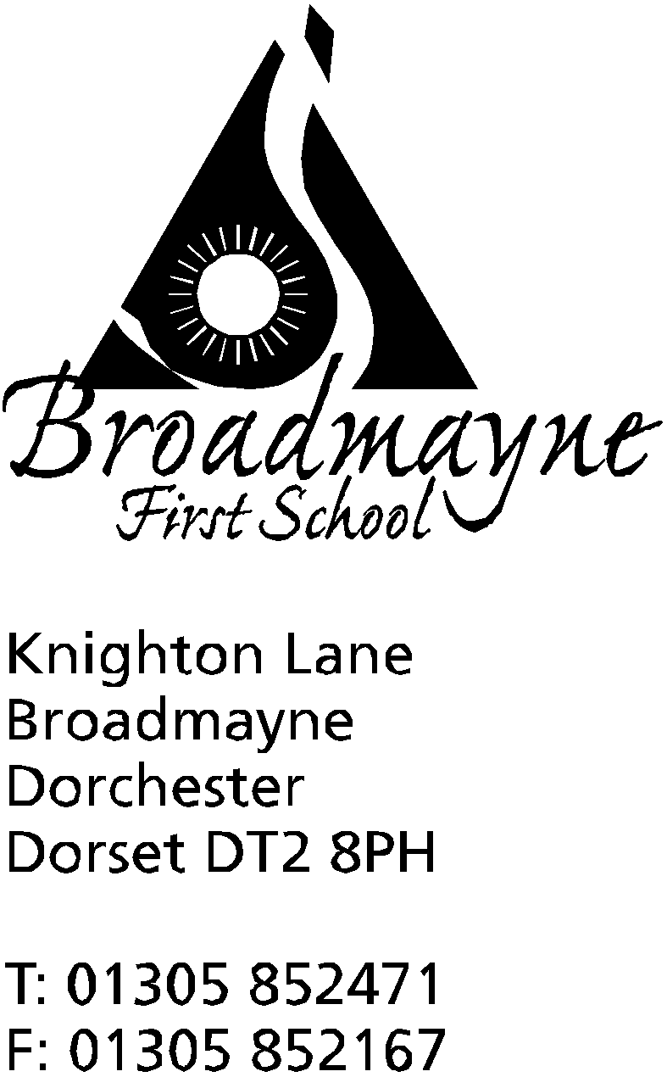

In Dorset

Headteacher
Helen Collings
Monday 27th April 2020

Dear Parents and Carers,

I hope you are all well as we enter the sixth week of the national lockdown. As I write to you, there is currently no further guidance on what will be happening either with the schools or the wider lockdown, although I anticipate extra government announcements this week as Boris Johnson returns to lead the cabinet. I am following what is happening in other countries with interest - for instance in Denmark primary children have returned to school, albeit with many restrictions in place, and Italy has set a date for September for a return. It is difficult to predict what our government will decide to do, but we hope that whatever they choose regarding the schools we are given enough notice to plan accordingly.

The school reports are being sent out to you today - the post is slow at the moment so they may take a little longer to get to you. The Year 1 - 4 reports were all written before the lockdown and so reflect your child’s learning and progress at that time. The attendance reported on is up to the day the school was closed for the national lockdown. I hope they will be of use to you - we do intend to hold parent/carer consultations once we are back at school. Reception parents will also receive a short written report.

I am sure that you, like me, have been inundated with various organisations offering a plethora of worksheets and lessons for you and your child. My advice is to pick and choose carefully - or ignore completely! Our staff are working hard to keep the work suggestions coming out to you, and I hope you all know by now that as a school we fully support your decisions on behalf of your family. Having said that, it may be that you would like to access some further support. Some links you might find interesting are:

CAMHS (Children and Adolescents Mental health Services) have a range of parent support materials here: https://www.camhs-resources.co.uk/?fbclid=IwAR1BALNEcyham6_g938ThIo9Lf7-dAUrglEISKeP8pgFWBoo7r8Qx31yEbg

BBC Daily lessons: https://www.bbc.co.uk/bitesize/dailylessons

Oak National Academy: https://www.thenational.academy/

ThinkUKnow online safety packs for children and parents: https://www.thinkuknow.co.uk/parents/Support-tools/home-activity-worksheets/?utm_source=Thinkuknow&utm_campaign=03f521e658-TUK_ONLINE_SAFETY_AT_HOME_21_04_20&utm_medium=email&utm_term=0_0b54505554-03f521e658-64791497

I have also attached a guide from Dorset reading Partners on reading for pleasure to this email (which has a link to my all time favourite book Mr Gum and the Biscuit Billionaire - Year 4 might enjoy this in particular!). Another addition to the reading for pleasure list would be the CBeebies Bedtime stories - read every day at 6.50 pm. This is available on the iPlayer and on the CBeebies channel This week the stories are being read by Tom Hardy, which might be of interest to some of the adults reading this!

As always, please look after yourselves, and if you are worried or concerned about anything I am always here to try and help - headteacher@broadmayne.dorset.sch.uk

Yours faithfully,

Mrs Collings

