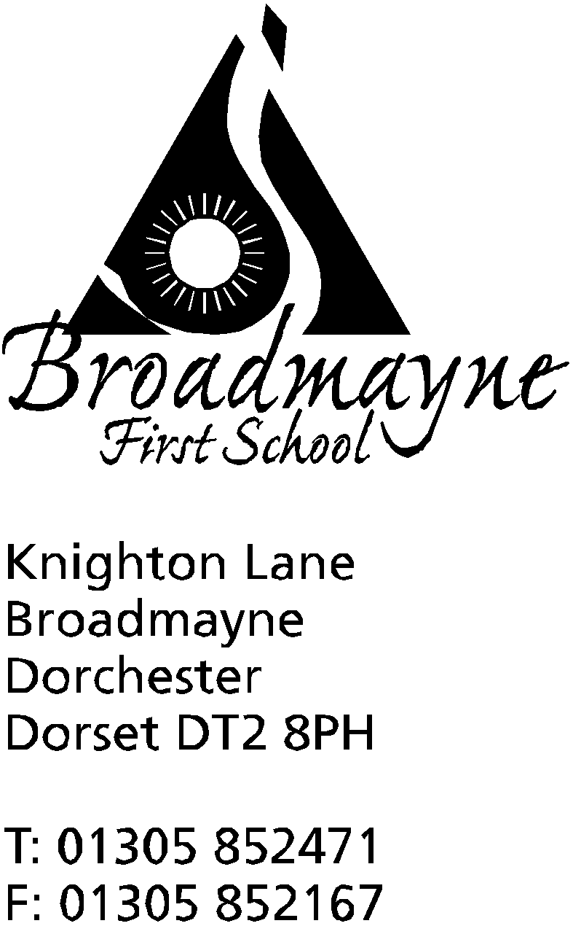

In Dorset

Headteacher
Helen Collings
25th January 2019

Spring 2019 - Newsletter 2

Things to remember: Plastic bottles and eco bricks
Week beginning 28th January is NSPCC Pants week - parent resources and information can be found on https://www.nspcc.org.uk/preventing-abuse/keeping-children-safe/underwear-rule/

Dear Parents and Carers,

Spring term has started well, and all the classes are busy with their new topics. We are still collecting 2 litre plastic bottles for our greenhouse, and plastic bottles stuffed with plastic for our eco brick project. Remember these need to be packed very tightly - we are finding wooden spoon handles or a chopstick very handy for ensuring every space is filled!

Well Being Term
Our well being term has started WELL. Years 2 and 3 are enjoying their Relax Kids sessions, and we are focusing on PSHE across all classes. Don’t forget the meditation sessions run by Mrs Simmonds are now being held on Wednesdays straight after school at £1 per child, and loosely follow the Relax Kids approach. Ms Carter and myself will be offering a workshop for parents soon on supporting children’s mental health -more details to follow.

Number Day
You may remember we took part in the NSPCC Number Day last year. This is a day to celebrate all things maths related, whilst also raising money for the NSPCC, a charity which provides valued support to both the school, parents and children. This year we will be supporting it again, and it will be on the 1st February. As it involves dressing up, I felt this would be a timely reminder! We would like to invite the children to come in to school dressed in anything that involves number - this could be a football kit, a spotty top - last year we had someone in a ‘two-two’! We would like children to also bring in a donation for the NSPCC. We will spend the day celebrating number - including inviting you all to come in for a ‘Learn Alongside your Child’ session at 9am, where you can join in with your child’s learning in class.

Year 1 Class Assembly
A huge well done to Year 1 who entertained us all with their class assembly last week. The children were so confident speaking in front of a large audience, and it was wonderful to see the pride they had in their hard work so far this year. It was a particular treat to see their Hawaiian dance once again!

Message from SchoolMoney
We have received the following message from the SchoolMoney Team:

With online payments on the rise, Eduspot (as providers of SchoolMoney) would like to remind you to be extra vigilant when making payments.
Recently, there have been a small number of reports of attempts to defraud parents whilst using SchoolMoney. We thoroughly investigate all reports of attempts to defraud parents using our system (including separate, independent checks) and can confirm that we found that no fraud, data breach or malicious attack has occurred.
We believe however, that it important to remind parents to be extra vigilant when making payments online. NEVER give out your ATM pin to anyone – no system or person should ever require this to complete an online transaction. If something looks suspicious, do not complete the payment, close down your browser and start again making sure you are using a genuine website.
You should also ensure all system and app updates are applied to your PC or mobile devices and that they have reliable, up-to-date anti-virus software installed. Increasingly, mobile devices are the targets of malicious software so it’s important that these also have adequate protection.
Eduspot remains committed to protecting your online security and providing you with an easy to use solution to securely make payments to your schools. If you spot something that doesn’t look right relating to SchoolMoney, please contact us at support@schoolmoney.co.uk.

DASP Music
Broadmayne First school was visited by the DASP Instrumental Roadshow this week.
The roadshow provided a fun way for the children to see a range of instruments being played by some of the DASP peripatetic teachers. All of the instruments that were shown are instruments which your child could potentially learn whilst they are at school.
Here is a list of instruments which are available to learn in your school (with suitable starting ages):
From year 2 upwards - piano/ukulele/violin/cello/recorder/trumpet
From year 3 upwards – clarinet/flute/oboe/bassoon/trumpet/trombone/French horn/guitar
(starting ages are a guide only)
We are really keen to get more children in the area learning orchestral instruments – particularly the woodwind and brass instruments.
Lessons can be organised within school hours from £4 per lesson (for a group lesson) and are taught by visiting teachers who are organised by DASP Music. More information about lessons and how to apply, can be found on the DASP Music website: www.daspmusic.co.uk
If you think that your child is not quite ready for formal instrumental lessons, but you would like them to get a grounding in musicianship, then we offer Colourstrings Musicianship sessions for KS1 children, held at Damers School on a Weds 3.45 – 4.30pm for £40 per term. Please contact us daspmusic@thomas-hardye.net if you would like more information on these sessions.
In addition to these lessons, we also run a number of ensembles which are suitable for first school children to join (for £30 per term):
Skylarks Choir – for years 2-4 . Damers school, Thursdays 3.45 – 4.30pm
Training Windband – for beginners to grade 2 wind/brass players. Thomas Hardye School , Wednesdays 4-5pm
Stringalings – for beginners to grade 2 string players. Thomas Hardye School, Wednesdays 4-5pm
Beginner ukulele group – for beginners. Thomas Hardye School, Wednesdays 4.30-5pm
Please contact us if you are interested in your child trialling any of these groups.
We hope your child enjoyed watching our roadshow and might be inspired to get involved with a musical activity in the future!

FABS
The FABs are currently in need of someone to take on the role of treasurer. Financial experience isn’t necessary, just an enthusiasm to help the FABs with this important role. The current role holders are very happy to take the time to train someone in the accounting system they use, and have kindly said they are happy to help with any accounting issues if anyone gets stuck! There would also be some banking duties, and counting of money (eg for a float for stalls). There are currently two people in this role, and the FABs are really happy for the role to be shared again if you feel this would work for you. If you would be interested, please let the school office know, or speak directly to one of the FABs.

Eco Schools
On Wednesday of this week the school was visited by Jill Hickman, our local Eco Ambassador. She visited the school to see if we were in a position to keep our Green Flag award. After speaking with Miss Felgate, our Eco Schools Coordinator, she met with the school Eco team and was taken on a tour of the school to see all the projects we are currently involved in. We now have to wait to find out the outcome of her visit - watch this space!

Yours faithfully

Mrs Collings
Calendar Dates

Date | Time | Event
JANUARY  Wednesday 30th | 8.15 am  Afternoon | Finance Governors Meeting  Reception Dance festival-St Mary’s Middle School
Thursday 31st | 2.30 pm | Hooke Court meeting for parents and children
FEBRUARY  Friday 1st | 9 - 10.10am | NSPCC Number day  Learn Alongside Your Child -maths focus
Tuesday 5th |  | Safer Internet Day
Wednesday 6th | 1.45 pm | Pantomime performance in school
Thursday 14th |  | Last day of half term
Friday 15th |  | INSET day
Mon 18th- Fri 22nd |  | Half term
Monday 25th |  | Return to School

